Reading and Responding to Your Baby

Care Group Volunteer Flip Chart

Lessons One to Six

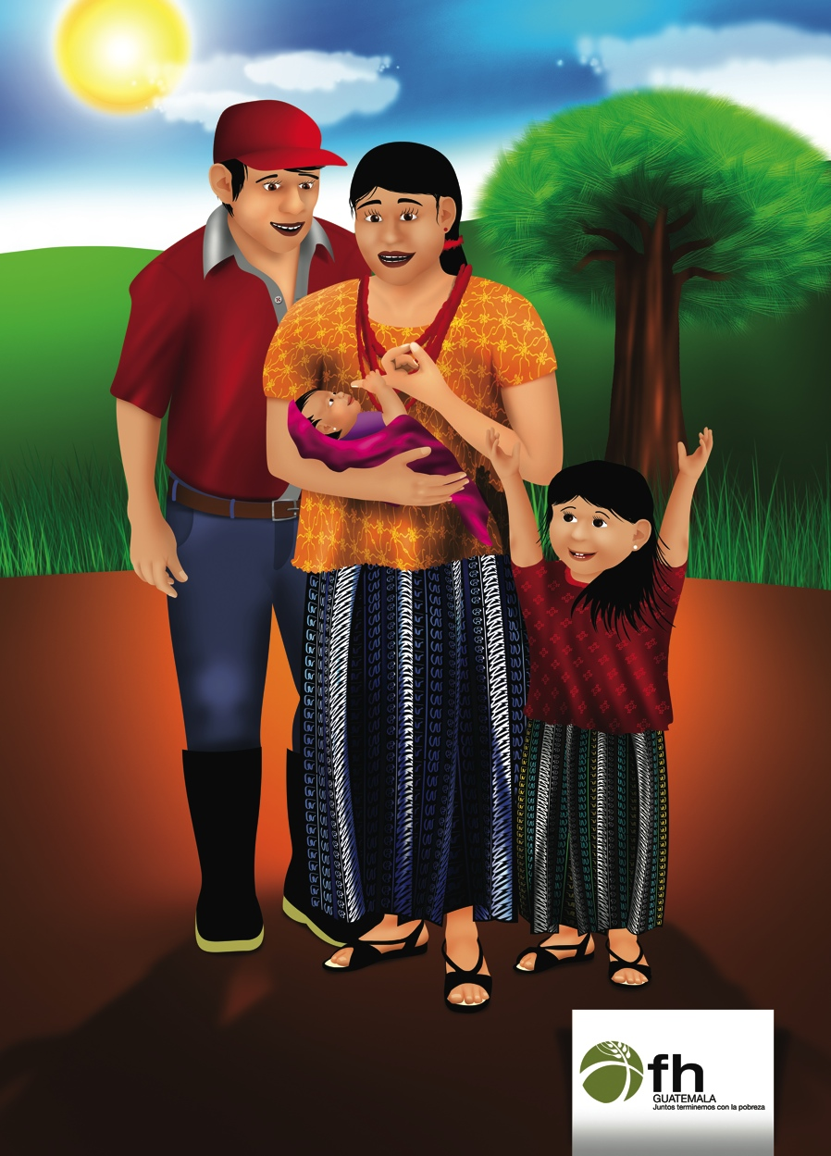

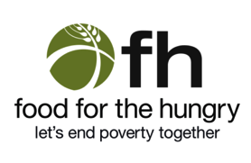

Acknowledgements
Many thanks to the artists who have contributed to this module, including Paola Gutierrez. Mary DeCoster, Mitzi Hanold, and Jana Torrico are greatly appreciated for reviewing and editing the materials. The Carolina Global Breastfeeding Institute at the University of North Carolina at Chapel Hill is greatly appreciated for their expertise in the content development of this module.

Suggested Citation:
Neiswender de Calani, Karen; Parry, Kathy; Labbok, Miriam. (2014) Reading and Responding to Your Baby. Washington DC. Food for the Hungry (FH). This TOPS Small Grants Program Improvement Award was made possible by the generous support and contribution of the American people through the United States Agency for International Development (USAID). The contents of the materials produced through the TOPS Small Grants Program Improvement Award do not necessarily reflect the views of TOPS, USAID or the United States Government.

This page was left blank intentionally.
Lesson 1: Speaking With Love to Your Baby

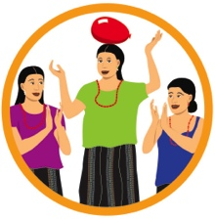 | 1. Game: People to People

2. Attendance and Troubleshooting

Maria’s Delivery (Picture 1.1)

Maria delivered her baby boy, David, at home. Her labor was long and difficult. After David was born, he was taken away by Maria’s mother-in-law. “Maria, you are very weak from giving birth and need to rest. Don’t worry about anything, I’ll make sure the baby is fed with rice water. Besides, you won’t have any milk in your breasts yet anyway.” She took David, wrapped him up, and left the room to give him some rice water she had prepared.

- How did Maria’s mother-in-law care for David? Why?
- What do you think about this situation? Has this happened to you?
- Who held and cared for your last baby right after he or she was born?

Let’s compare your experiences with the messages on the following pages.

Maria’s Delivery

Babies Communicate From Birth (Picture 1.2)

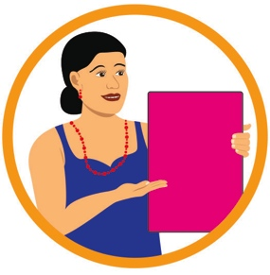 | 5. Share the Meaning of Each Picture

- What do you think these pictures mean?

Newborns begin communicating right after they are born.
  - Babies are very smart and can let caregivers know exactly what they need. Their language is the use of their face, body and voices.
  - Babies let mothers know they want to be close so they can feel Mama’s heartbeat, smell her skin, and find her breast for her first thick milk (colostrum). If babies are anywhere other than mother’s belly/chest after delivery, they may communicate their unhappiness by crying and searching for mama’s smell.
  - Staying open and receptive to what our babies are telling us will help us learn their language.
  - Start talking with your baby, so he or she feels loved and part of the family.
  - Speaking with Love to your baby is a special communication between the two of you.
- How do babies communicate with their mamas? What do they do?
- Did your baby communicate with you after she was born? What did she say and how did she say it?
Babies Communicate From Birth

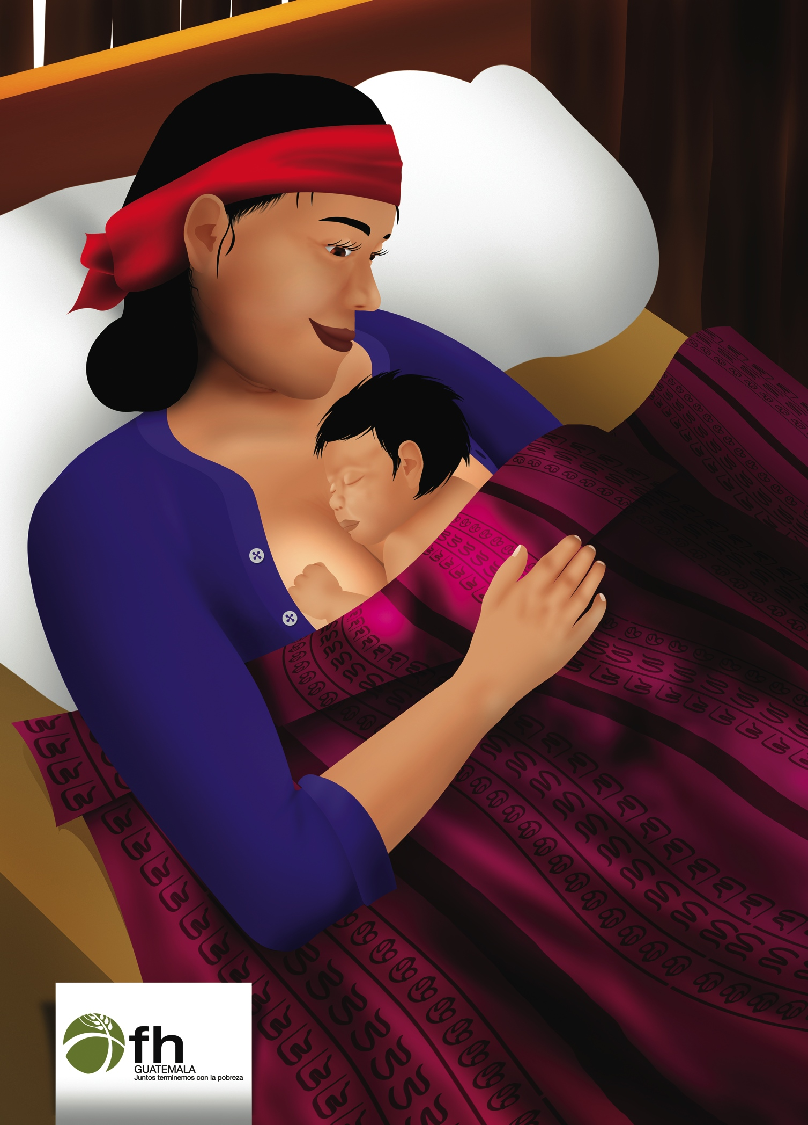
Babies Want to Be Skin-to-Skin with Mama After Birth (Picture 1.3)

6. Share the Meaning of Each Picture

? What do you think these pictures mean?

Skin-to-skin with mama is the best place for newborns to be.
  - Wanting to be skin-to-skin is the first way your baby communicates with you.
  - Skin-to-skin contact keeps the baby warm and healthy.
  - It helps the baby adjust to the difficulty of being born.
  - When the baby can smell you, it leads to immediate breastfeeding.
- What happened right after the birth of your children?
- Do mothers in this community hold their babies skin-to-skin right after they are born? Why or why not?
- ¿Las madres de ésta comunidad ponen a sus bebés piel sobre piel justo después de su nacimiento? ¿Por qué o por qué no?
Babies Want to Be Skin-to-Skin with Mama After Birth

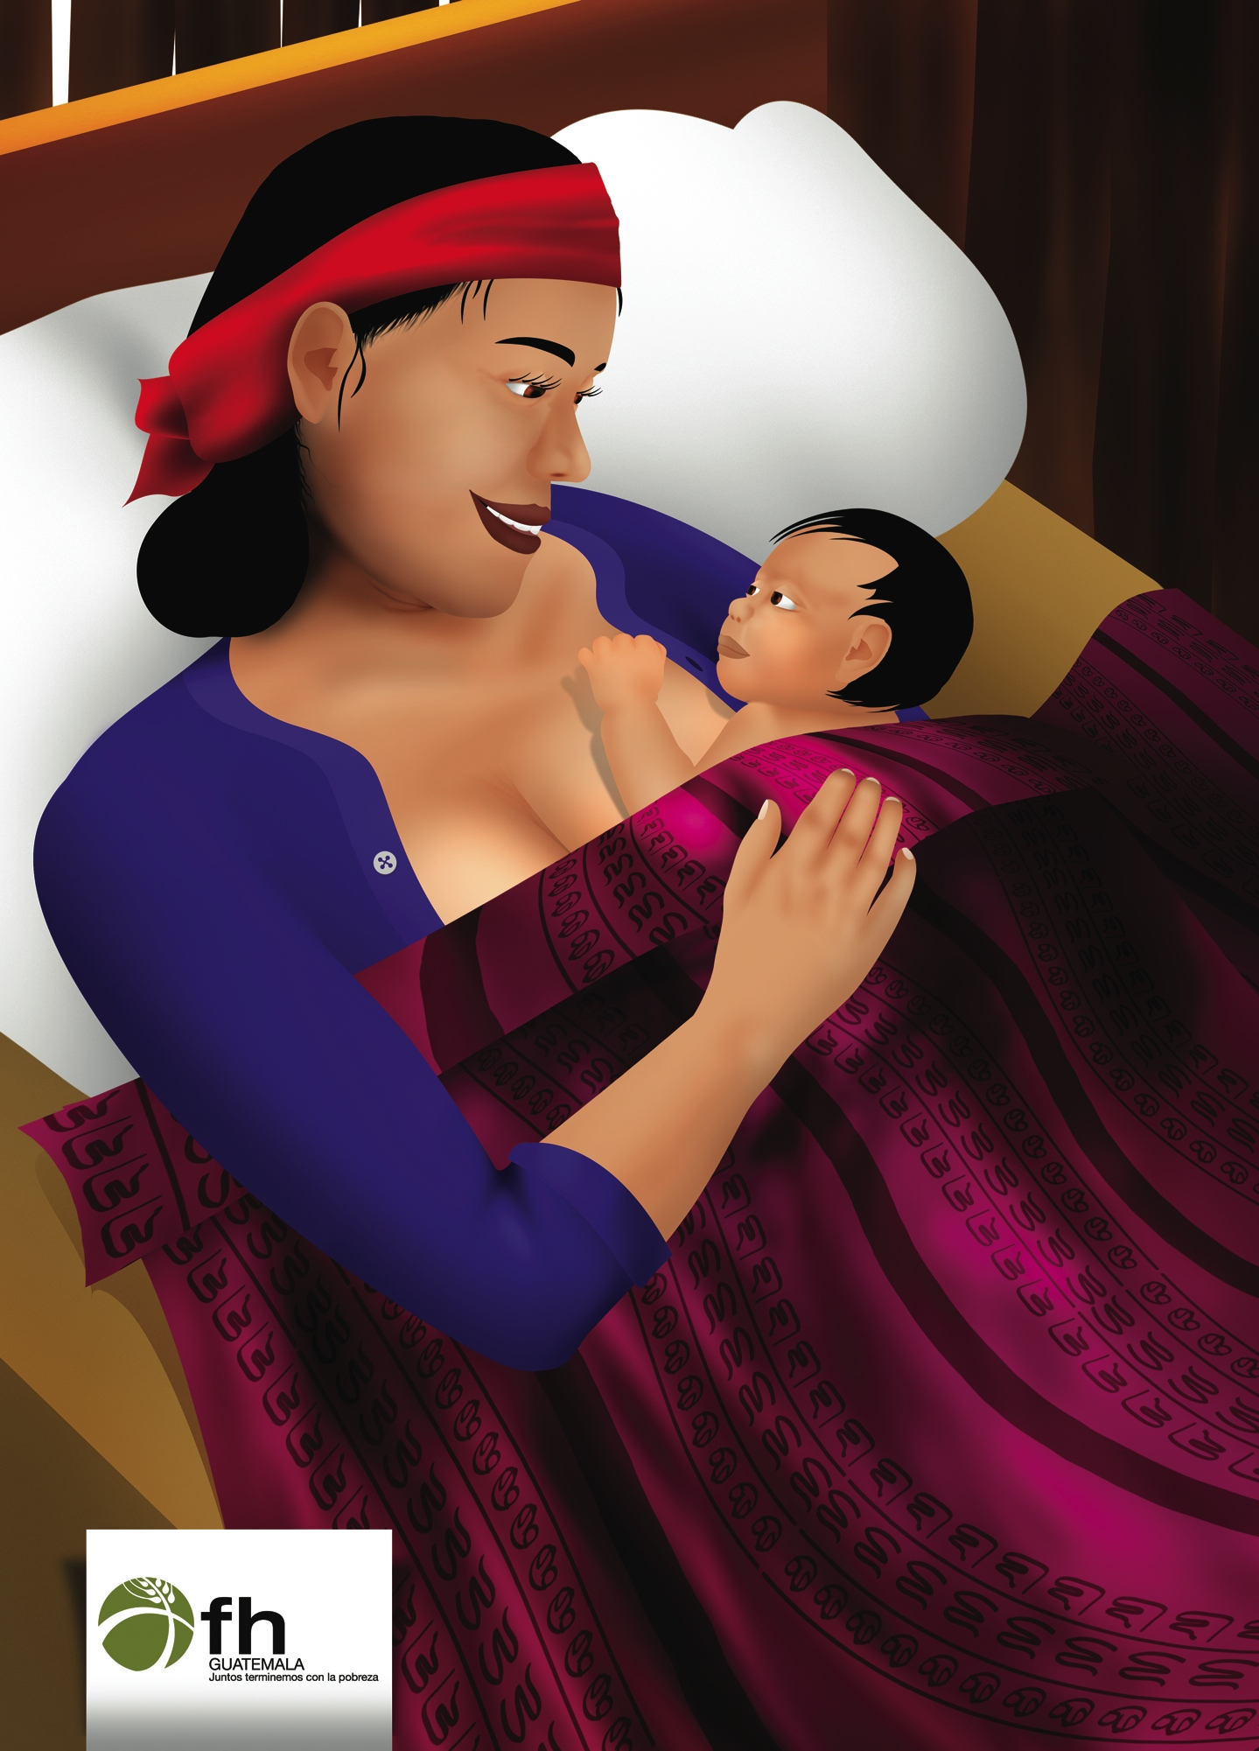

Breast Milk is All Your Baby Needs from Day 1 to 6 months! (Picture 1.4)

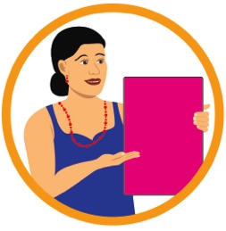 | 7. Share the Meaning of Each Picture

- What do you think these pictures mean?

The first thick milk (colostrum) protects babies from illness and helps moms get well.
  - Good for Mom: Early breastfeeding lessens bleeding and helps the placenta to come out of the mother; Breastfeeding early and often encourages mothers’ mature, abundant milk to come.
  - Good for Baby: First milk is concentrated and contains many vitamins and nutrients that protect infants from getting sick; it also naturally cleans the stomach of the infant over the first 2 days of life by expelling the first feces.
  - Feeding liquids other than mothers’ milk can cause baby to become sick and weak. Do not feed your baby rice cereal, formula, cornstarch drink, chicory honey, chamomile and anise teas, coffee and any other food or liquids.
  - So your baby will grow healthy and strong, feed only breast milk and nothing else until 6 months when they are ready for small portions of mashed up family foods after breastfeeding.
  - Breastfeeding is best even when you are sick or your baby is sick.
  - Breastfeeding is best even when you are pregnant!
- What do women in this community believe about the first thick milk?
- Did you feed your last child the first thick milk? Why or Why not?

Breast Milk is All Your Baby Needs from Day 1 to 6 months!

Children are Gifts (Picture 1.5)

8. Share the Meaning of Each Picture

- What do you think these pictures mean?

All children are gifts.
  - We have been entrusted with respecting them, listening to them, responding to their needs, and providing the best health for them.
  - Exclusive breastfeeding with no other liquids is one way we can take care of this special gift.
- Do you believe that all children are gifts? Why or why not?
- How should this belief affect the way you care for an infant?
- Are some children in your community given less attention than others? Why?

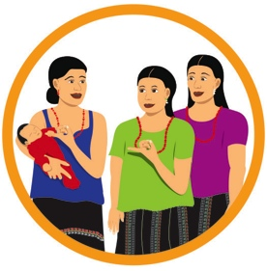 | 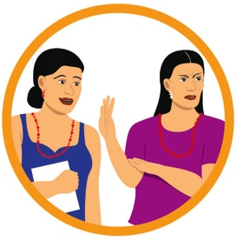 | 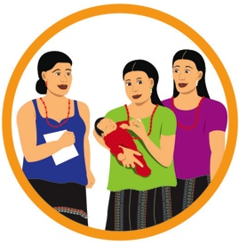 | 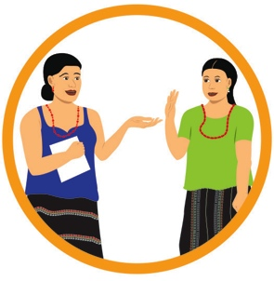
ACTIVITY:  Tummy Size of Newborns | Discuss Barriers | Practice and Coaching | Request Commitments

Children are Gifts

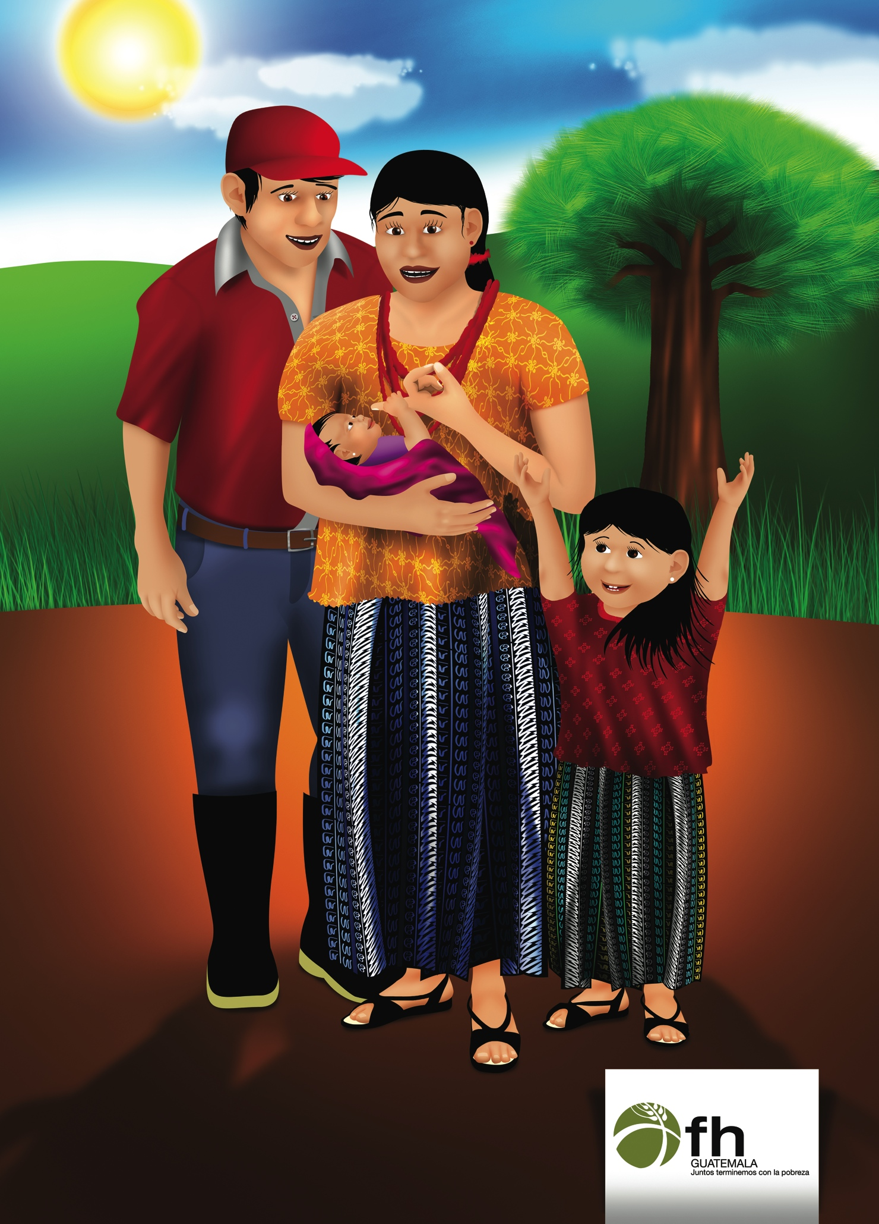

Lesson 2: Communicating With Your Baby During Breastfeeding and Mealtimes

1. Game: Showing our Emotions

2. Attendance and Troubleshooting

Esther’s Mealtime (Picture 2.1)

Dominga is a happy mother to nine-month-old Esther. She also has 2 other children. At mealtimes, Esther is now starting to pick up little chunks of food on her own and put them in her mouth. Dominga is overjoyed and begins doing other activities with her older children while Esther is placed in front of her food alone. Esther starts off well, but then sees no one is paying attention. She becomes upset, fussing and throwing food, eventually crying. Dominga quickly realizes why Esther is crying and consoles her. The other children come over to the table and together, the whole family talks and smiles with Esther while she eats.

- Why did Esther get upset at being left alone to eat? What did she do to tell her mother what she needed?
- What did Dominga do to help Esther eat her food? Why?
- How do you feed your older babies?

Let’s compare your experiences with the messages on the following pages.

Esther’s Mealtime

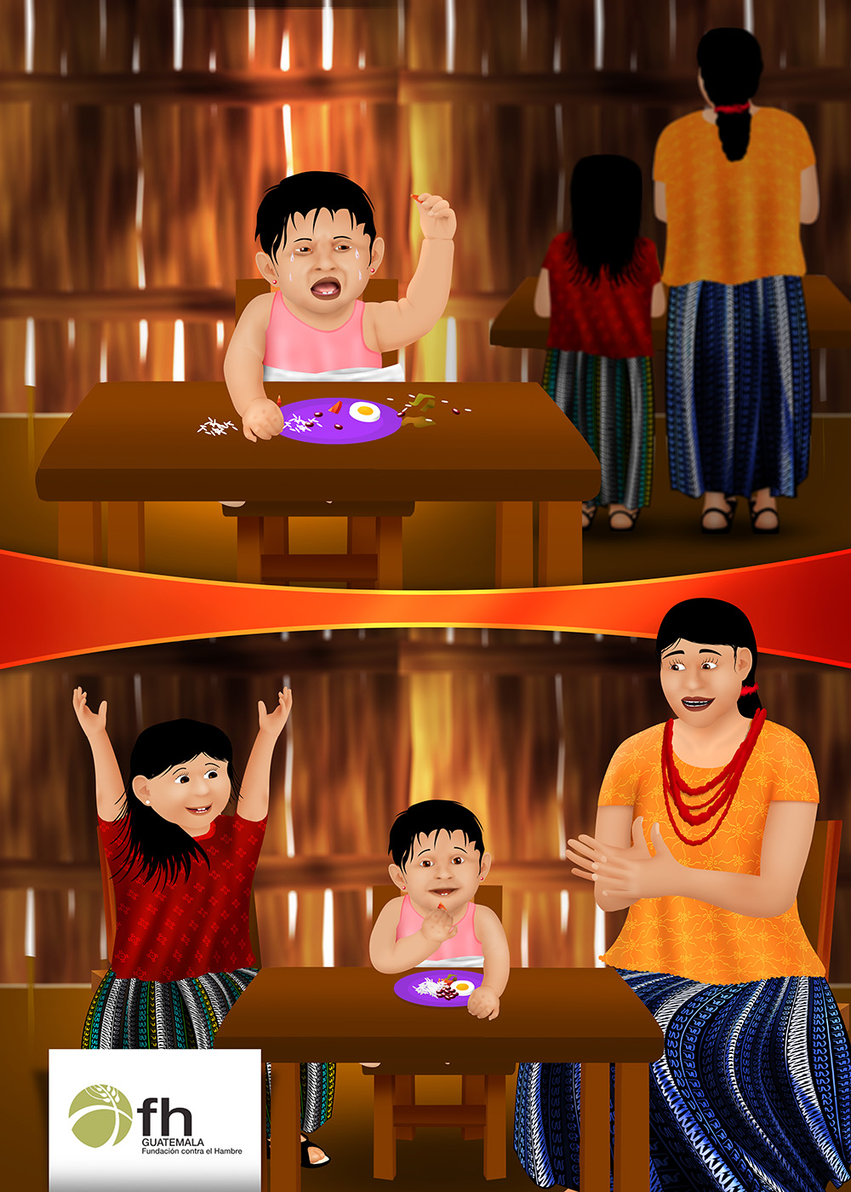
Communicating While Your Baby Eats is Healthy (Picture 2.2)

5. Share the Meaning of Each Picture

- What do you think these pictures mean?

Talking and playing with your baby while he or she eats makes your baby feel loved and happy. Many babies eat well and grow better when caregivers talk with them during breastfeedings and mealtimes.
  - Communication with newborns can be through eye contact, touch, using your voice to talk to your baby in different ways (soothing, playful), or by playing games and singing together (The Woodcutter; The Tortilla Maker).
  - This helps newborns to staying awake during breastfeeding. Even when your older baby can grasp foods on her own, it is good to enjoy time with her and help her during meals.
  - Communicating with your baby while he or she eats will help keep her interested in the activity of “mealtime”. She will be less distracted by other activities going on around her. Babies become disinterested in the food if no one is there with them. Babies who eat without help from an adult can choke on their food or eat too little.
  - This also helps encourage your baby to eat the right amount of food and grow stronger.
- Do people in your community talk and play with their babies while they eat or breastfeed?
- What is mealtime like in your household?
- Was it hard with your previous children to keep them interested in eating? What did you do to help them eat?

Communicating While Your Baby Eats is Healthy

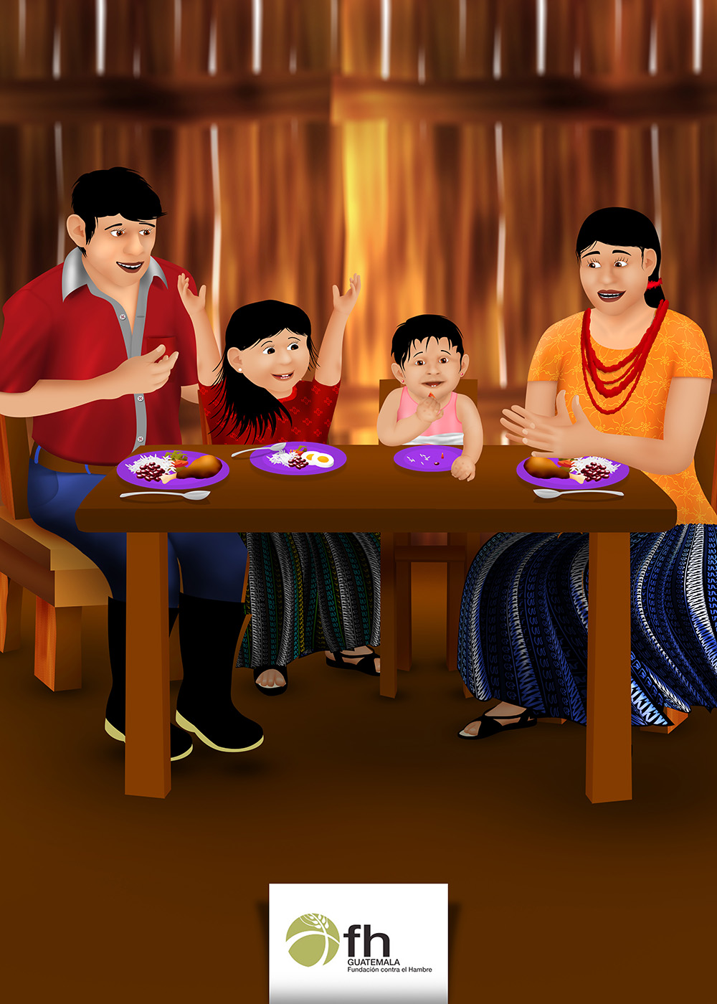
How Do Babies Tell you That They Want to Play? (Picture 2.3)

6. Share the Meaning of Each Picture

? What do you think these pictures mean?

Babies will show signs of “engagement” when they are ready to play and communicate.
      - Eye contact, eyes following you as you move, bright open eyes
      - Smiling, cooing sounds, vocalizations and laughing
      - Smooth arm and leg movements
      - Reaching out to you
- What are some ways your baby tells you she is ready to play?
- How do you feel when you respond to her the right way (the way she wants you to)?

How Do Babies Tell you That They Want to Play?

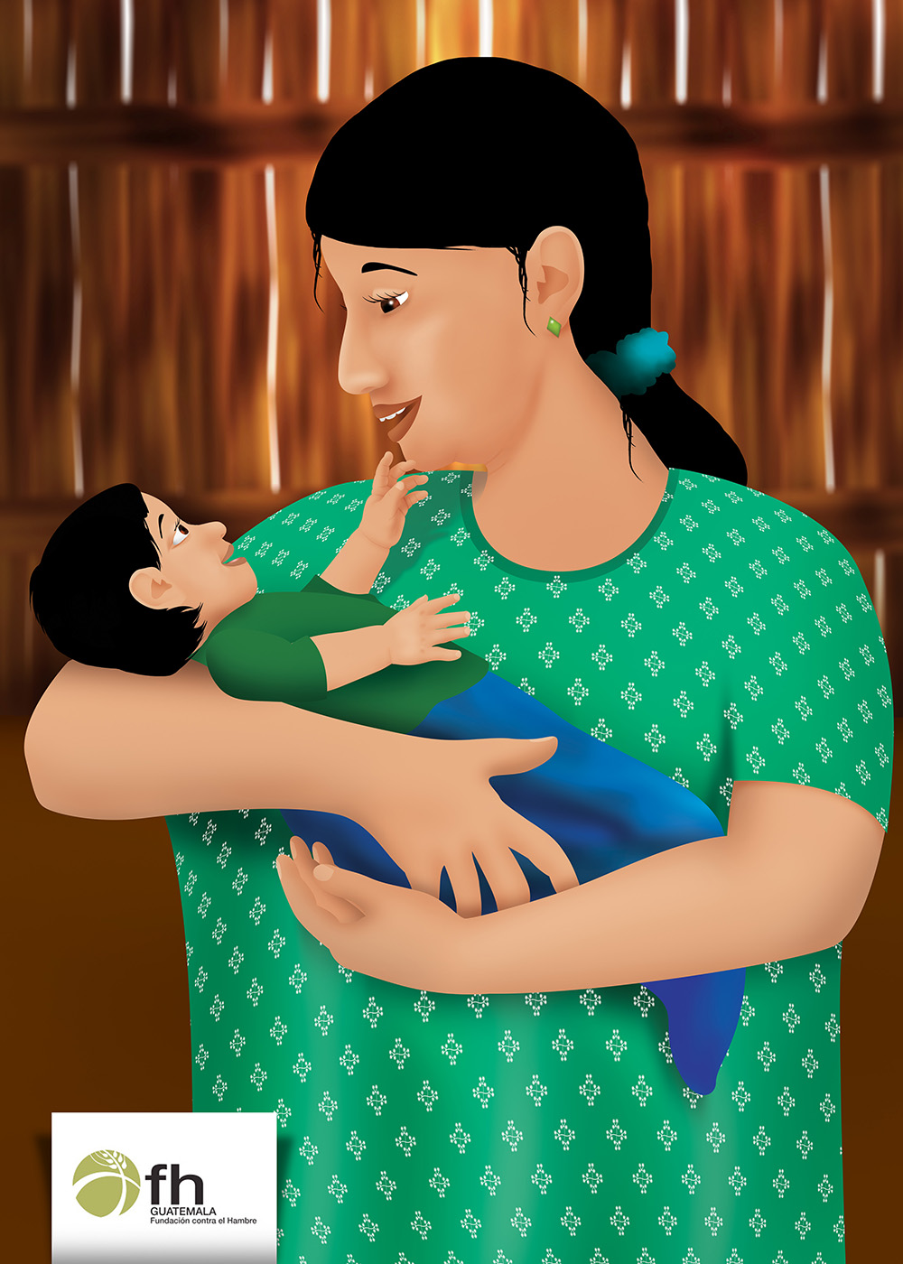

How Do Babies Tell you That They Want to Rest? (Picture 2.4)

7. Share the Meaning of Each Picture

- What do you think these pictures mean?

Babies will show signs of “disengagement” when they need a break from stimulation and play.
      - Biggest sign is babies will look away from you
      - Turn head away from your face
      - Jerky arm and leg movements
      - Squirm or roll over away from you
      - Fuss or cry
Babies will want to be played with and talked to most of the time. This communication with adults is how babies learn and develop their brain and coordination. Stop the stimulation if your baby shows signs that she needs a break.
- What does your baby say or do when she is tired or sleepy?
- How do you feel when you discover what your baby is trying to tell you?

How Do Babies Tell you That They Want to Rest?

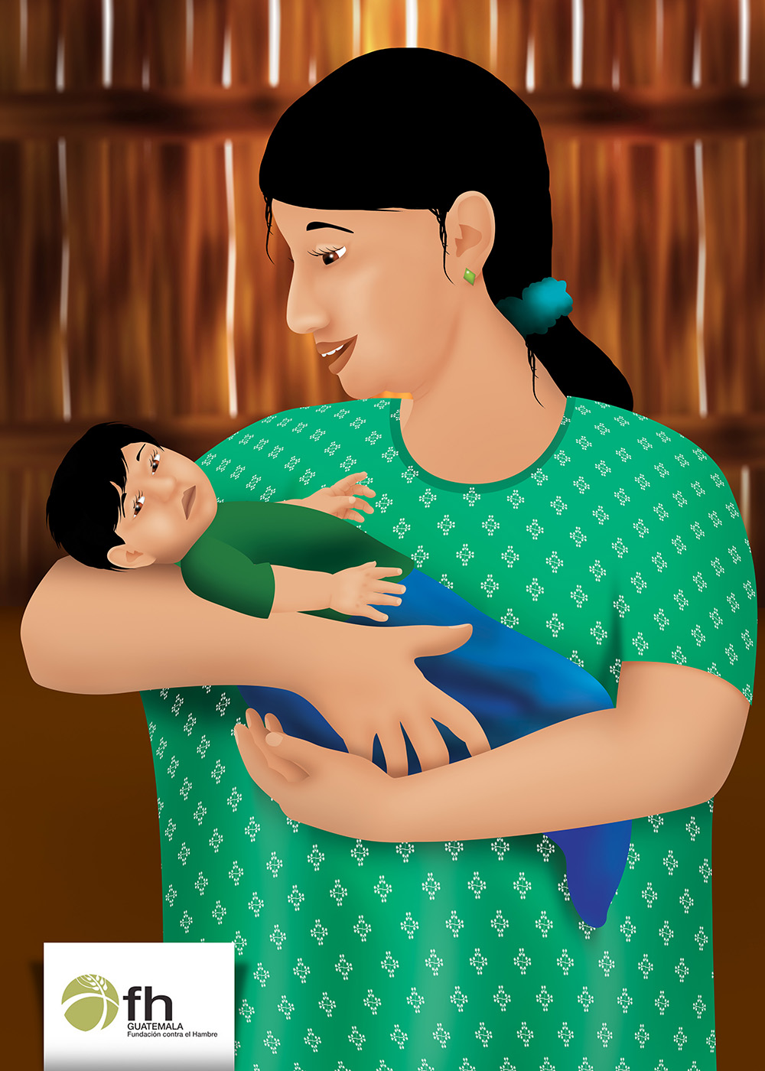

Communicate with your baby even when you are busy (Picture 2.5)

8. Share the Meaning of Each Picture

- What do you think these pictures mean?

Babies love to be included in what adults are doing.
- When you are carrying your baby in her shawl, you can do your chores and communicate with your baby at the same time. Point out colors, shapes, or other interesting things to your baby. Sing to your baby while you are working.
- Show older babies how helpful they can be. For example, putting objects into a bucket can be a helpful task that also helps babies develop and practice new skills while playing.

Talking and playing with our children during feeding times and involving them in our daily chores builds our love for one another and improves the life and health of our children.
- What are things that you do to communicate with your baby while you are doing chores?
- What are some ways you’ve found to include your older babies in your chores?
- What gifts to you have to share with your children?

ACTIVITY: Baby Sing-a-Long! | Discuss Barriers | Practice and Coaching | Request Commitments

Communicate with your baby even when you are busy

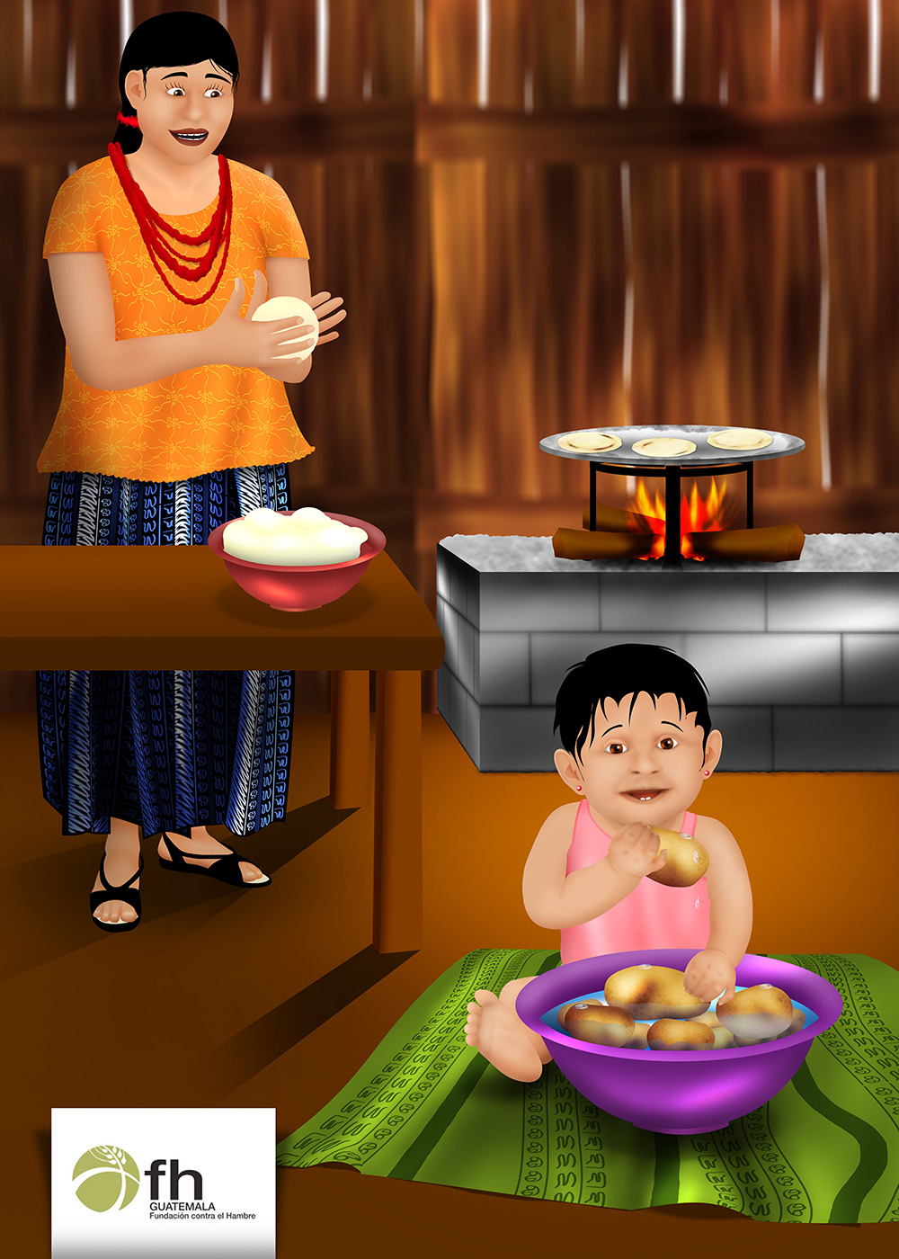
Lesson 3: Reading and Responding to Hunger Cues

1. Game: I’ve Never

2. Attendance and Troubleshooting

David Needs Help Growing (Picture 3.1)
Maria has three older children as well as David, who is now 3 months. She does her best to play with all her children, but she is often busy with many chores. David spends much of his time in a shawl across Maria’s back while she is doing the housework and caring for her other children. David is content to be there and cries when he is hungry. But, David has been looking thin and weak, and did not gain weight this month. Dominga, her Care Group Volunteer, said he is not getting enough to eat. Dominga suggested that Maria wear David in front a little more often, so she could talk and play more with him throughout the day. This has helped Maria see that David is telling her when he is hungry. It turns out he was asking to eat many more times per day than Maria had noticed, but he didn’t cry until he was really hungry!

- What did Dominga notice about David?
- What was her suggestion to Maria? Is it normal to wear babies in the front? At what times?
- How do you know when your babies are telling you they are hungry?

Let’s compare your experiences with the messages on the following pages.

David Needs Help Growing

How Do Babies Say They Are Hungry? (Picture 3.2)

5. Share the Meaning of Each Picture

- What do you think these pictures mean?

Babies will tell you when they are ready to eat. Feed your baby when you see her do these things. First Signs of Hunger in Infants 0-5 months:
- Nuzzles into the breast or bobs around, searching for nipple
- Brings hand to mouth or sucks on hand
- Sucks on tongue or lips, or sticks tongue out
- Turns head to the side and opens mouth (rooting reflex)

Babies will cry if their previous cues for feeding have been missed. Try to notice early signs of hunger and respond early to avoid an upset baby. Calm baby before starting to feed. Babies drink more milk when they are calm.
- Fussiness or crying
- Tight fists, brought in toward the middle of the body.
- Baby may have a wrinkled forehead, look worried or unhappy.

Stop and feed your older baby when he does these things. Signs of Hunger in Babies 6-12 months:
- Licks lips, excited arm and leg movements
- Pulls on mama’s shirt
- Reaches out for food with hands
- Points at food or asks for food with words or other sounds.

Once feeding has begun, babies indicate they are eager for more by:
- Smiling, cooing,
- Making eye contact with the caregiver
- Opening mouth and moving forward in the direction of food
- Moving hand to reach spoon.
- How does/did your newborn let you know she was hungry?
- Have you ever noticed any of these hunger signs in your children?
- How do you know when young babies are ready for foods or liquids other than breast milk?

How Do Babies Say They Are Hungry?

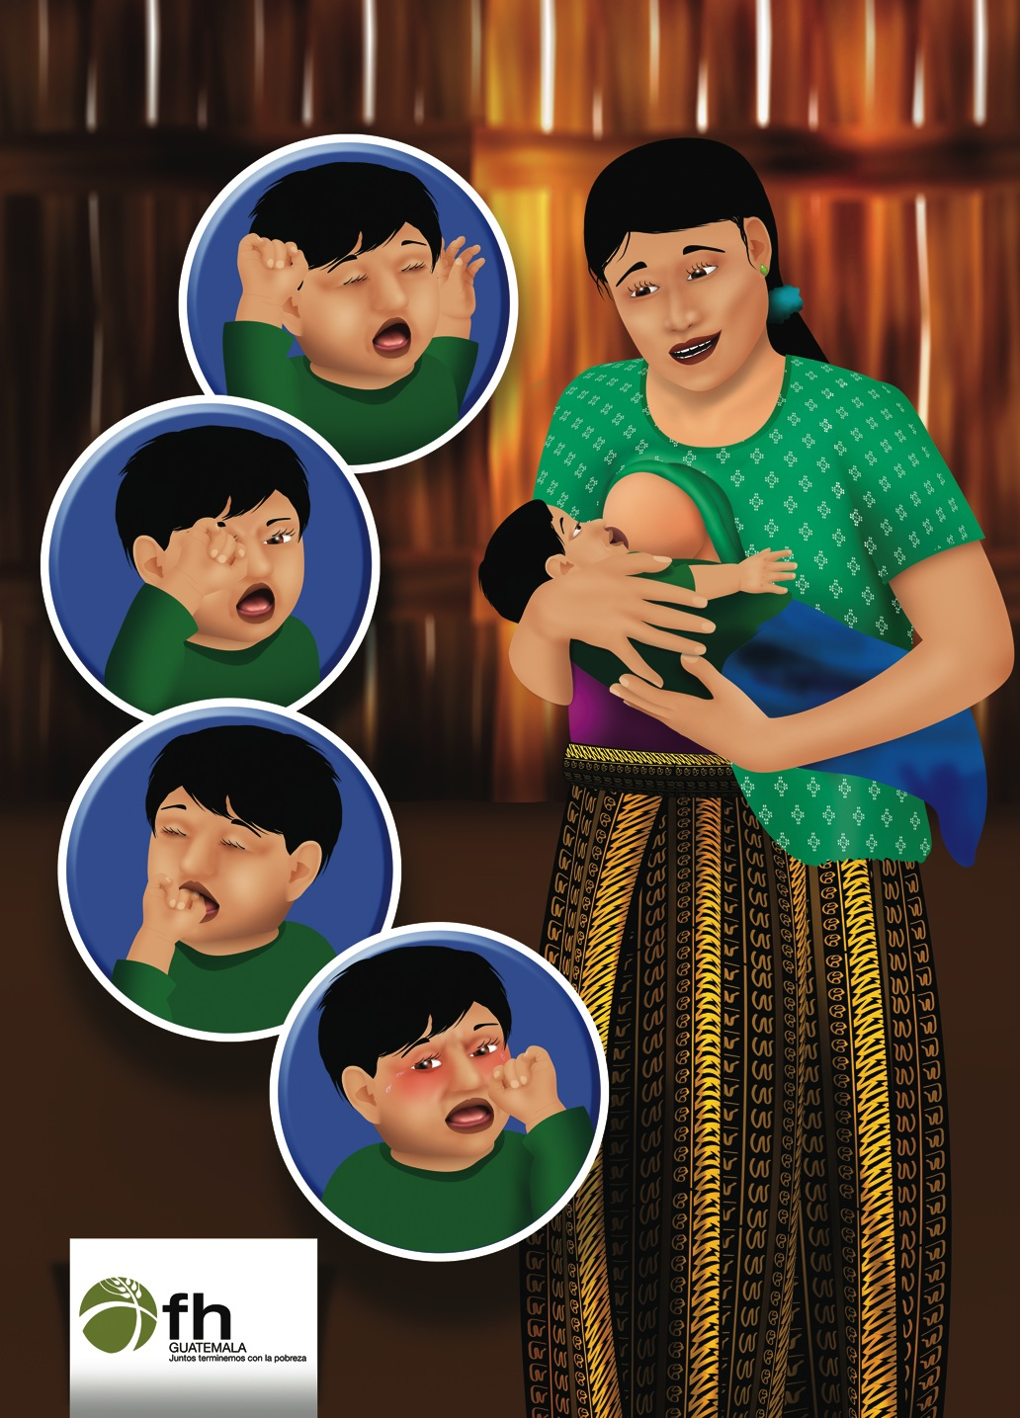
How Do Babies Say They Are Full? (Picture 3.3)

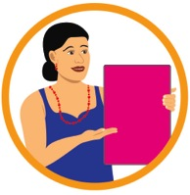 | 6. Share the Meaning of Each Picture

? What do you think these pictures mean?

Babies may appear to be satisfied after just a small amount of food or a short time of breastfeeding, but it is important to encourage them to eat until they are full.
- Many babies don’t gain weight or grow well unless they are encouraged to eat more and breastfeed longer.
- Babies can become distracted once the feeling of hunger goes away, but mothers should not mistake this for fullness.
Babies know best when they need to eat and when they have had enough. Signs of Fullness in Infants 0-5 months:
- Very relaxed arms and legs that fall outward away from the body
- Baby stops sucking
- Falls off the breast and does not search for it again
- Falls asleep at the breast (though, some young babies will need help staying awake to get enough milk)
- Refusal of nipple if offered again

Signs of Fullness in Babies 6-12 months:
- Baby eats slower
- Plays with food or plate/cup
- Refusal or pushing spoon of food
- Closing mouth to offered food
- In older babies: Shakes head or says, “No”

Babies have many gifts. They are very smart already. They can tell their mamas when they are hungry and when they are full.
- Has your baby ever done any of these things while eating? Which ones?
- What does your baby do to tell you he is full?
How Do Babies Say They Are Full?

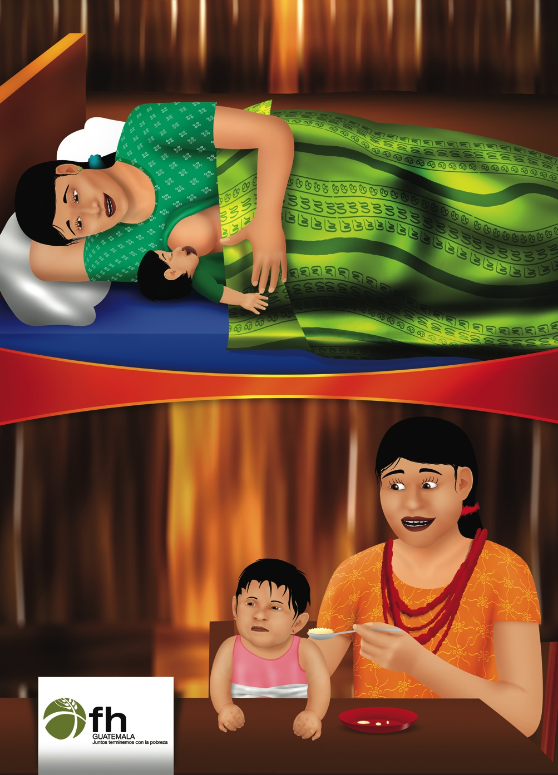

Food Refusal (Picture 3.4)

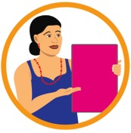 | 7. Share the Meaning of Each Picture

- What do you think these pictures mean?

Sometimes babies who are hungry may still refuse food.
- They may be getting to the stage where they want to feed themselves.
- Try placing a few small chunks of food in front of your baby and let her know she can do it all by herself.
- Stay with your baby and encourage her through this process by speaking to her with Love.
- Does your baby ever refuse food? Why?
- What do you do when this happens?

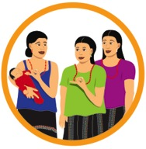 | 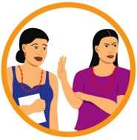 | 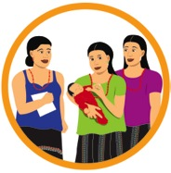 | 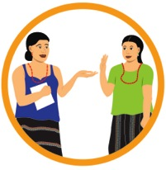
Activity: Hunger & Fullness Cues | Discuss Barriers | Practice and Coaching | Request Commitments

Food Refusal

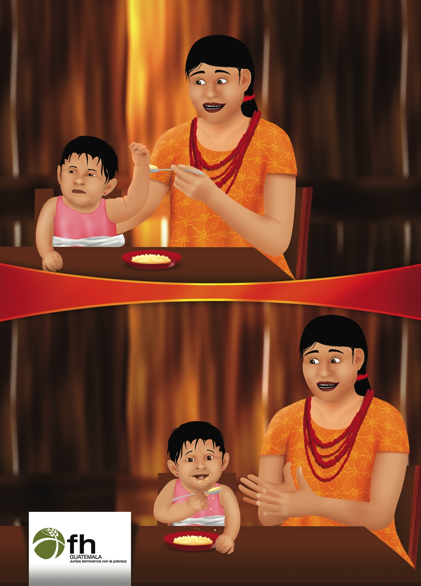

Lesson 4: How To Feed Responsively

1. Game: Memory

2. Attendance and Troubleshooting

Bella’s Tantrum (Picture 4.1)
Maria is learning how David tells her that he is hungry. She is also watching for signs of hunger in her sister’s daughter, Bella, who is visiting today. She is almost 1 year old and is learning to feed herself. One day, while Maria was still preparing lunch, Bella began pointing at a banana. “Oh, no!” thought Maria. “Lunch is still not ready. Maybe I can distract Bella with her doll.” Bella began to play with the doll and forgot about eating for a while. Later, just as everyone was sitting down to eat, Bella began crying and screaming for food, but was too upset to eat. Maria wished she had just fed Bella when she was hungry, then the mealtime would have been pleasant for everyone.

- How did Maria respond to her niece, Bella? Why?
- How should Maria have responded to Bella? Why?
- Has something like this every happened to you? What did you do?

Let’s compare your experiences with the messages on the following pages.

Bella’s Tantrum

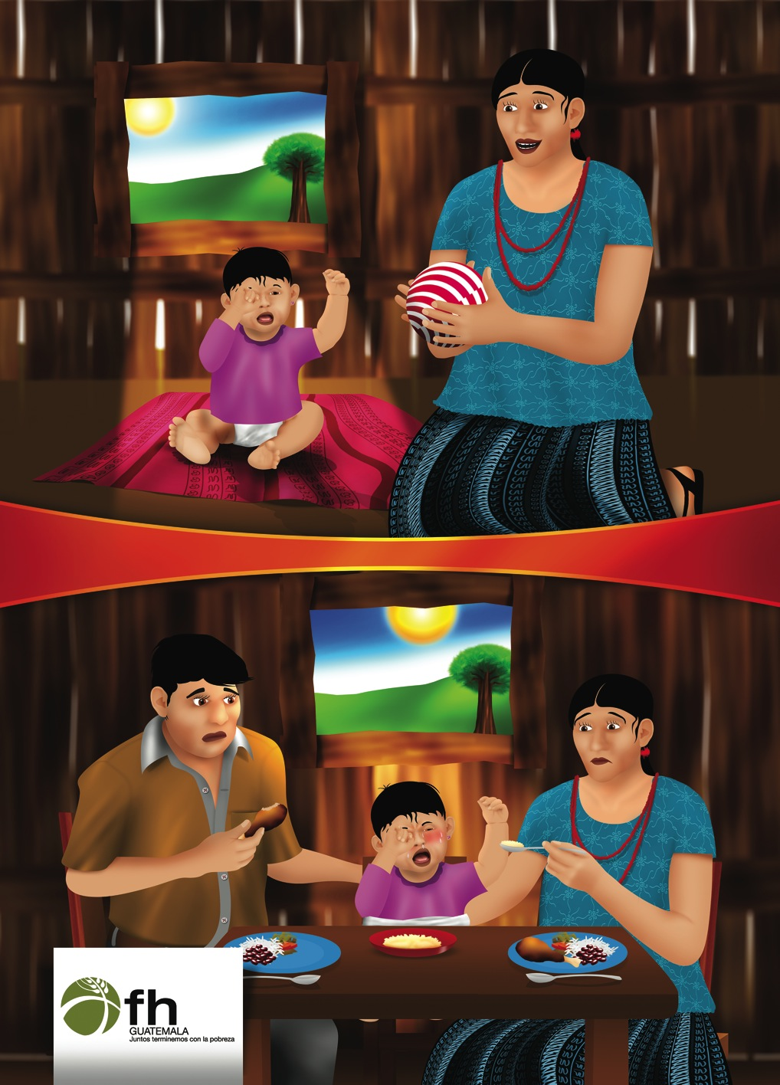
Respond Quickly To Hunger and Fullness Cues (Picture 4.2)

5. Share the Meaning of Each Picture

- What do you think these pictures mean?

When you notice hunger signs in your baby, let her know you understand and prepare to feed her as soon as you are able. If breastfeeding, offer the breast immediately.
- Pay attention to your baby’s signs while feeding. If you notice signs of fullness, allow the baby to take a small break before offering her more.
- Do not force your baby to eat. Let their hunger and fullness signs guide you. (Very new babies may be sleepy and need to be awakened for regular breast feedings.)
- Offer the meal (breast milk or solids) slowly and patiently to your baby. He may refuse food if it is offered too quickly. Feeding with warmth and support help to keep him interested.
- For snacks, offer a nutritious food that does not require cooking, such as a tortilla with beans, or fruit.
- Never put food in a bottle. Your baby may choke.

Do not try to distract your baby or ignore her signals that she is hungry.
- How do feedings go if you are rushed and impatient? What about when you offer food slowly and patiently?
- Do women in your community respond immediately to a child’s signs of hunger? Why or Why not?
- What are some of the signs for hunger and fullness that we learned recently? Have you been able to identify them in your children?
Respond Quickly To Hunger and Fullness Cues

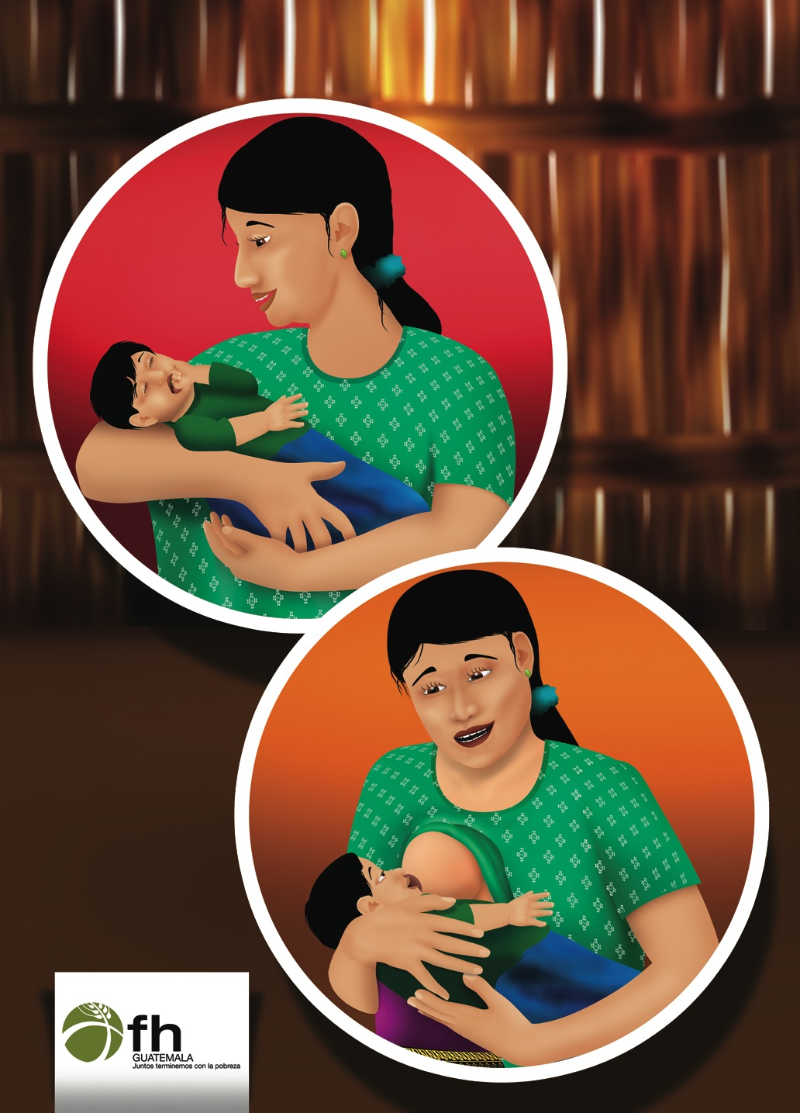
Speak with Love to your Baby During Feeding (Picture 4.3)

6. Share the Meaning of Each Picture

? What do you think these pictures mean?

Offer words of love and affection to your baby while you are breastfeeding or during mealtimes. Do this at other times throughout the day and night, as well.
- Congratulate or praise your baby for feeding well. This will encourage him to continue doing this behavior.
- Let your baby know that getting enough food is important to you. Babies are happy when caregivers are happy.

Speaking affectionately during mealtimes let’s your baby know she is loved and valued.

- What are some words or phrases you use to speak to your baby with love? What do you say to speak with love while your baby is eating?
- How do you let your children know they are of great worth and value to you?
- Do you notice other women doing this in your community? What types of loving words or phrases do you hear others say to their children?

Speak with Love to your Baby During Feeding

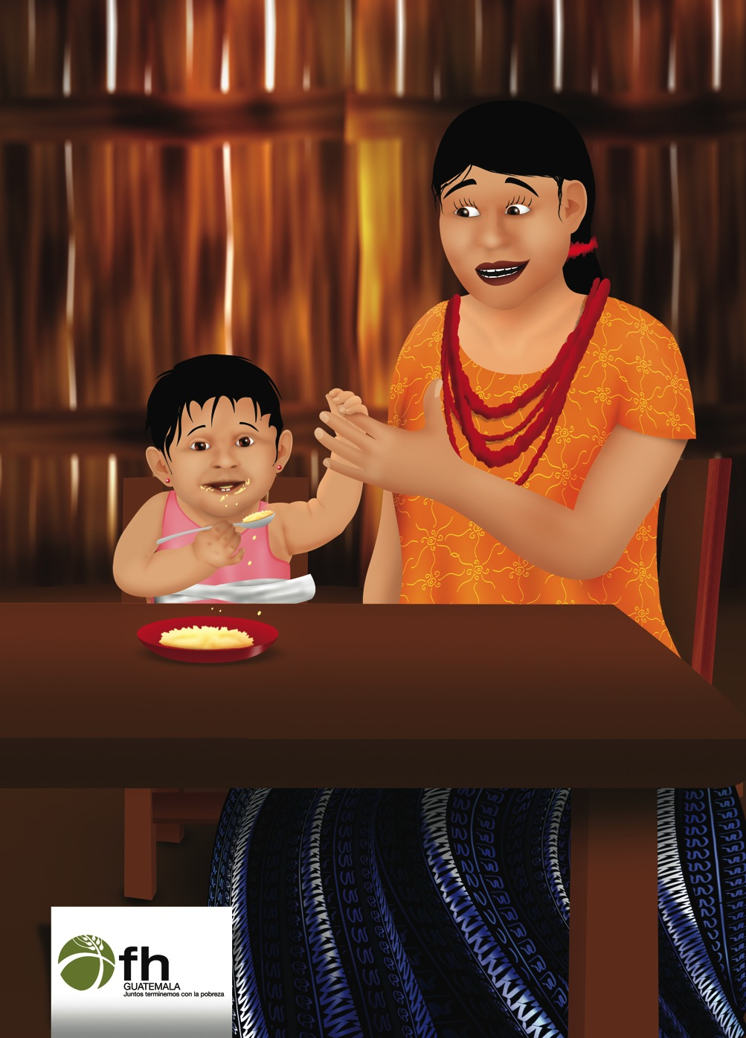
Creating Pleasant Routines for Mealtimes (Picture 4.4)

7. Share the Meaning of Each Picture

- What do you think these pictures mean?

Mealtimes will be more pleasant if you prepare a little in advance. Here are some things you can do:
- Try to offer meals at the same times each day that your child is likely to be hungry. Routines of sitting at the same place at about the same times each day will help your child look forward to this activity.
- Make sure your child is seated comfortably, facing you and/or others who may also be eating.
- If breastfeeding, make sure you are comfortable and not distracted.
- Be sure to let your child know what is expected of her as you sit with her. Tell her about the delicious food she will be eating in a loving, affectionate manner.
- Use a separate bowl/plate and utensil for your child. Place appropriate portions in your child’s bowl before placing the food in front of them and helping them to eat.
- Make sure the foods you offer are healthy and appropriate for her age (mashed up or cooked well until soft).

By creating a pleasant mealtime routine for our children, we are using our gifts.
- How do you offer your young children snack or meals? What is your routine for feeding your children?
- Do you tend to offer meals and snacks around the same time each day? Why?
- How do you talk to your baby about mealtime or snack time? Do you talk with excitement, encouraging them to eat as much as they would like of the food in front of them? If not, why?

Activity: Speaking with Love | Discuss Barriers | Practice and Coaching | Request Commitments

Creating Pleasant Routines for Mealtimes

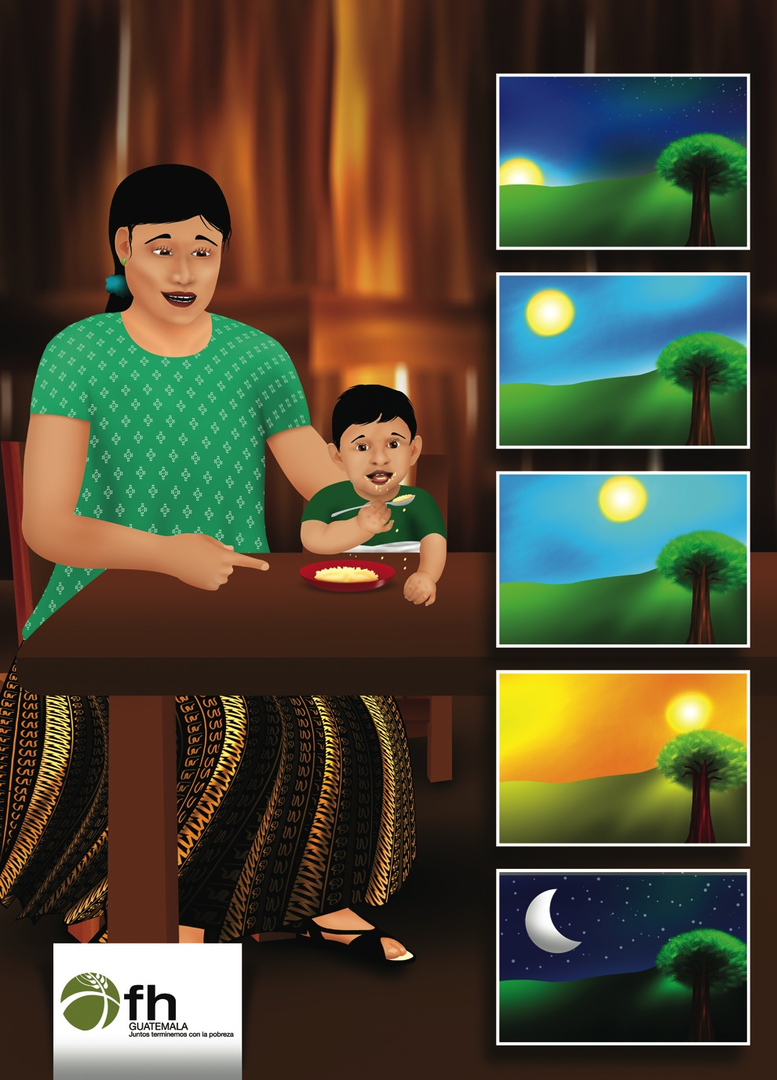

Lesson 5: Responsive Feeding Tips

1. Game: Simon Says

2. Attendance and Troubleshooting

David is Hungry Again (Picture 5.1)
David is now 9 months old. Maria knows David is a gift and that she must feed him well to keep him healthy. She prepares porridge for David three times a day. But he often grows hungry and cries between meals. Maria doesn’t always have time to cook for David many times each day. Today, she is busy washing the family’s clothes but David seems more fussy than usual. Her husband sees David is hungry and sits down to share a mango with him. He gives a piece to David and, as David puts the mango in his mouth, he congratulates him for doing it all by himself.

- What is keeping Maria from feeding David more often? What did her husband do to help her?
- How often do you feed your 9-12 month old child? Why?
- What do you do while your child is eating?
- What can Maria do to make it easier for her to feed David more often?

Let’s compare your experiences with the messages on the following pages.

David is Hungry Again

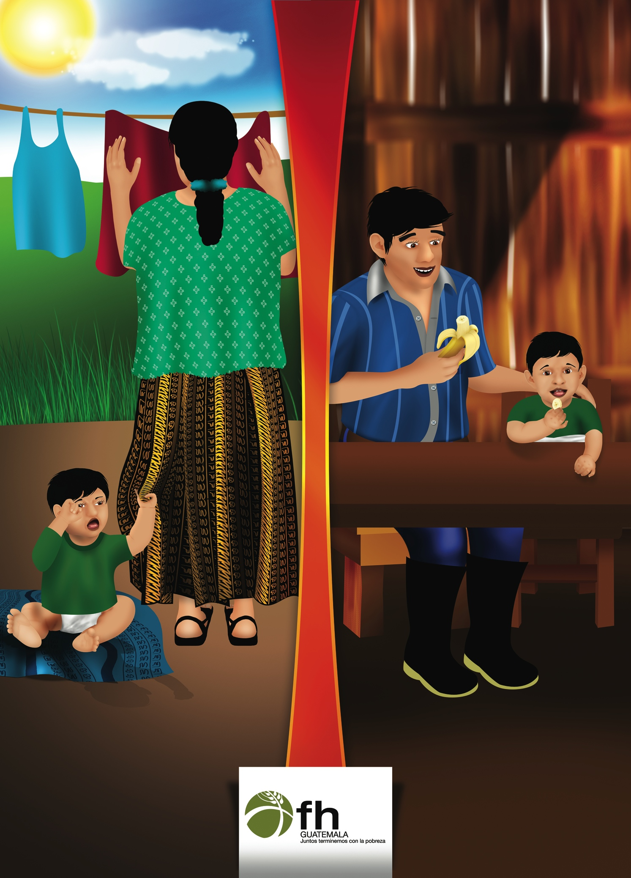
Responsive Breastfeeding Tips for Growing Babies (Picture 5.2)

5. Share the Meaning of Each Picture

- What do you think these pictures mean?

It is important to fully empty your breast during a feeding because the milk that your baby drinks when your breasts are almost empty has the most cream, which helps your baby gain weight.
- Allow your baby to breastfeed until she comes off the breast on her own. She may just need a break to release some air. Try placing her upright for a few minutes to burp. Offer the same breast again to fully empty it.
- Once one side is fully emptied and soft, offer the other side to your baby if she will take it.
- Newborns need to breastfeed 10-12 times per day for healthy growth and development. However, offer the breast to the child as often as she shows signs of hunger.
- Wake up weak or very sleepy babies and encourage them to eat. Some very young newborns sleep through their hunger until they learn that eating makes them feel good.

Breastfeeding remains the best food, even when babies begin to eat other foods.

Continue to offer your breast milk to your growing child as long as you both desire. Breast milk has many beneficial nutrients for growth and development. It is recommended to breastfeed a baby for at least 2 years.
- Do you usually offer your breast again after the baby has come off? If not, why?
- Until what age do women in your community breastfeed their children?
- How often did/does your newborn breastfeed during the day and night?
Responsive Breastfeeding Tips for Growing Babies

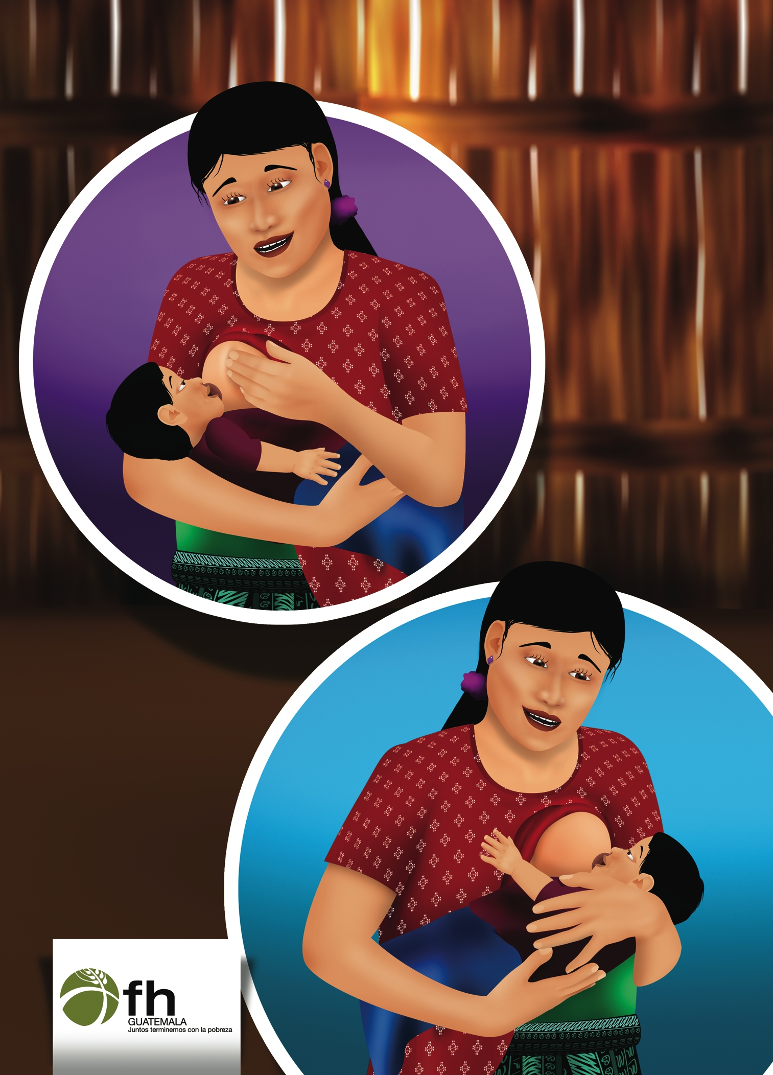
Responsive Feeding After 6 Months (Picture 5.3)

6. Share the Meaning of Each Picture

? What do you think these pictures mean?

Look for hunger and fullness cues in your child and respond with what they need. Feed your child slowly and patiently, never forcing the child to eat, but speaking with love to him.
- Feed younger babies (6-12 months old) yourself.
- Help older children (12-23 months) feed themselves. When your child is old enough to grasp objects well, place food in a bowl and encourage him to pick some of the pieces up on his own! Pieces should be smaller than the width of your finger.
- Give your child her own plate or bowl to eat from.
- Sit next to your child while she eats, or eat with her, encouraging her to eat more or to try feeding herself.
- If your child is easily distracted by what is going on during meals and snacks, try to minimize activities while he is eating.
- Look at your baby while he is eating. This is another way to encourage him to eat more food. It makes meal times fun and enjoyable.

- Which of these feeding activities have you tried with your child at home? What else do you do to help your child eat well?
- Which of these feeding activities are easy for you to do at home? Which ones might be more difficult?

Responsive Feeding After 6 Months

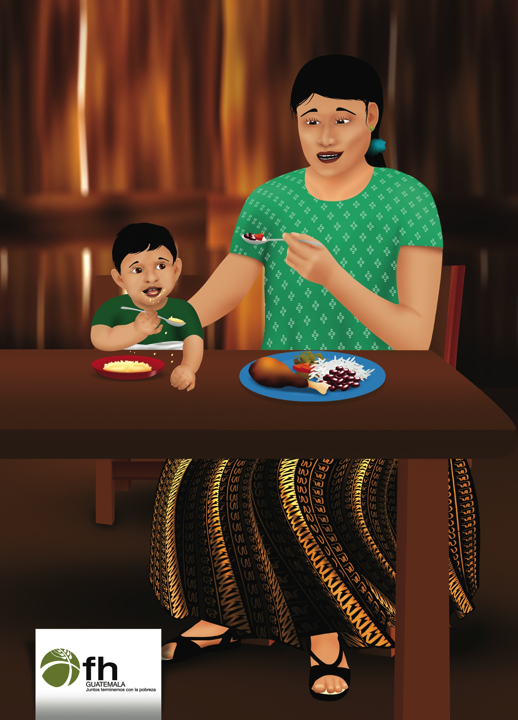
What Foods Are Best? (Picture 5.4)

7. Share the Meaning of Each Picture

- What do you think these pictures mean?

Offer as much variety of foods as you can. Try offering different combinations of foods at different times. Notice what foods and food combinations your child likes or dislikes. Let her know you’ve noticed what she likes.
- Foods for babies aged 6-8 months include: mashed up fruits like bananas and avocados, mashed up cooked vegetables like ayote squash, guisquil, and potato, and thick porridges made from grains like oats or root vegetables like malanga, yucca, hichinta or sweet potato.
  - Add protein and iron to mashed up vegetables such as leafy greens, tomatoes, scrambled eggs, mashed beans or ground peanuts. Ground up tortillas can also be added to the diet.
- For babies aged 9-11 months, foods that can be added to their diet include: small, chunky pieces of fruits like mango or bananas, vegetables like carrot, tomato, broccoli, sweet potato, and proteins such as chicken, cheese, scrambled eggs, or mashed beans.
- Babies 1 year or older need foods that are cut up into small enough pieces that they can easily feed themselves without putting too much into their mouths at once.
- Increase the variety of your baby’s diet with additional family foods not given previously.

We have a variety of foods to help our children grow and develop. These are good gifts that bring life to our families.

- What are some ways you can add variety to the foods you offer your family?
- What can you do to make sure your baby doesn’t choke on foods?
- What foods are available in this community that you can use to feed your children?
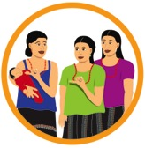 | 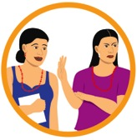 | 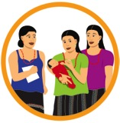 | 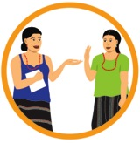
ACTIVITY: Child Feeding Song | Discuss Barriers | Practice and Coaching | Request Commitments

What Foods Are Best?

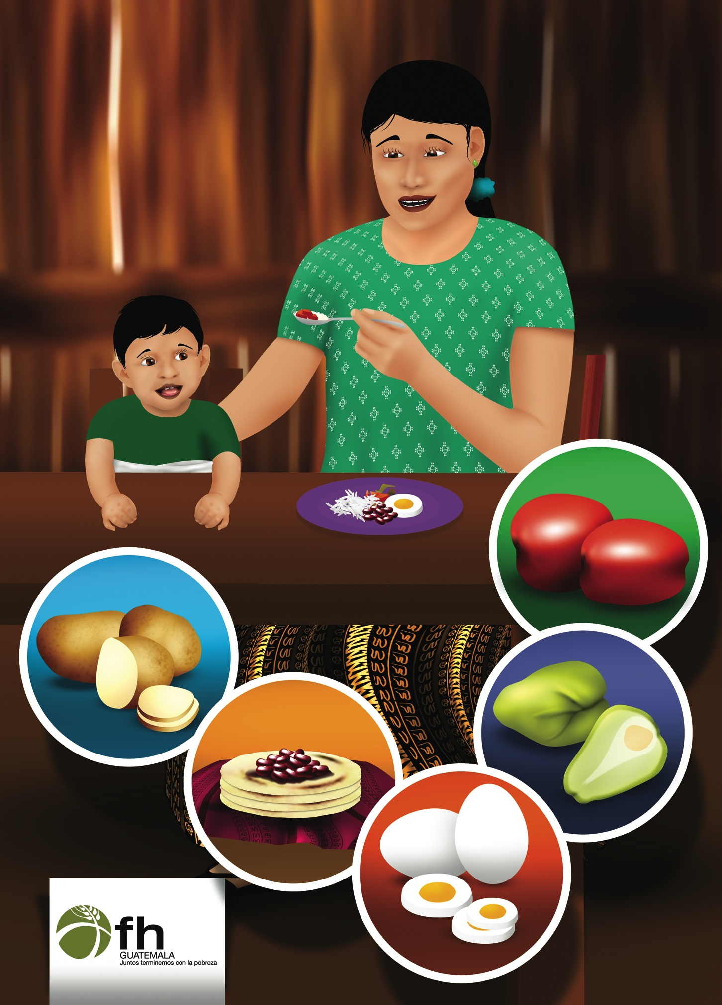

Lesson 6: Teaching Others Responsive Feeding

1. Game: Who is the Leader?

2. Attendance and Troubleshooting

Teaching Others in the Family (Picture 6.1)
As Maria has learned to recognize when David is hungry and respond with love, she has seen David grow healthy and strong. She has learned to use her many gifts to care for her family. But, when others help feed David, they often forget about him and don’t give him the attention he needs! Instead they are talking to each other, or paying attention to the older children. This makes David upset – he cries, throws food and doesn’t eat well. Maria realizes she needs to teach others in the family some of the things she has learned about how to feed David well!

- What makes David upset when other family members feed him? How does he respond?
- What can Maria do to show her family how to feed David well?
- What have you learned about how to feed your child with love?

Let’s compare your experiences with the messages on the following pages.

Teaching Others in the Family

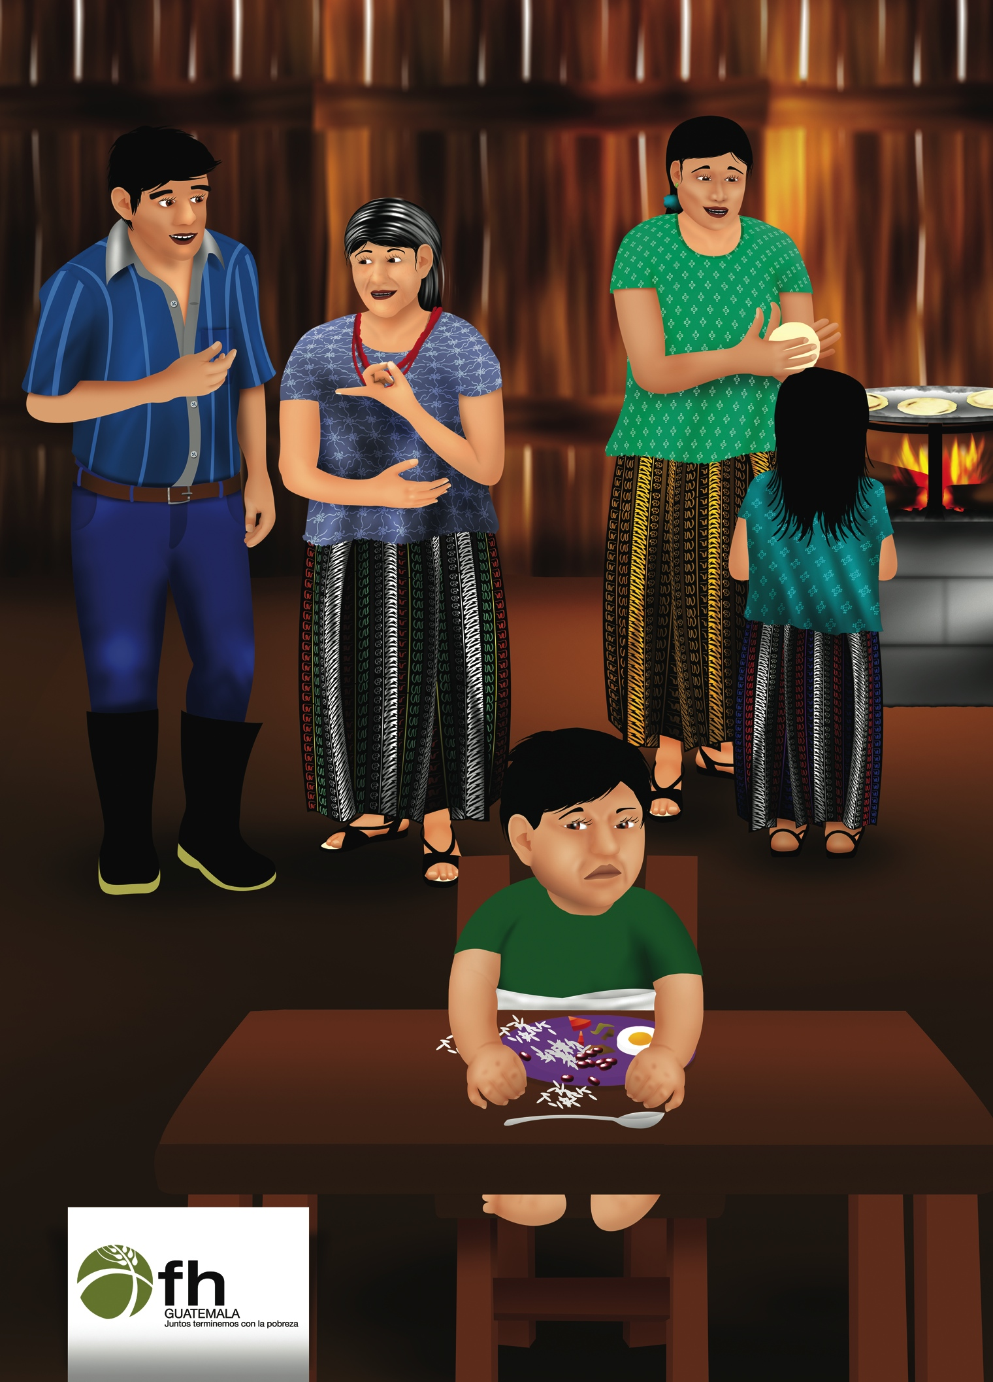
Your Family Can Help Respond and Feed with Love (Picture 6.2)

5. Share the Meaning of Each Picture

- What do you think these pictures mean?

All members of the family can respond and feed babies with love. This builds love within the family.
- Your husband can help recognize hunger cues and respond to your baby’s needs with love and affection. Including the father makes the child feel like he belongs with both of you.
- Show older children how they can be gentle and loving with your baby. Children can mimic the facial expressions they see in the baby. Babies like to be included in the family fun.
- Help family members with these behaviors by including them in mealtimes and showing them how to play games, speak affectionately, and encourage your baby to eat.

- How will you show your family how to feed responsively?

Your Family Can Help Respond and Feed with Love

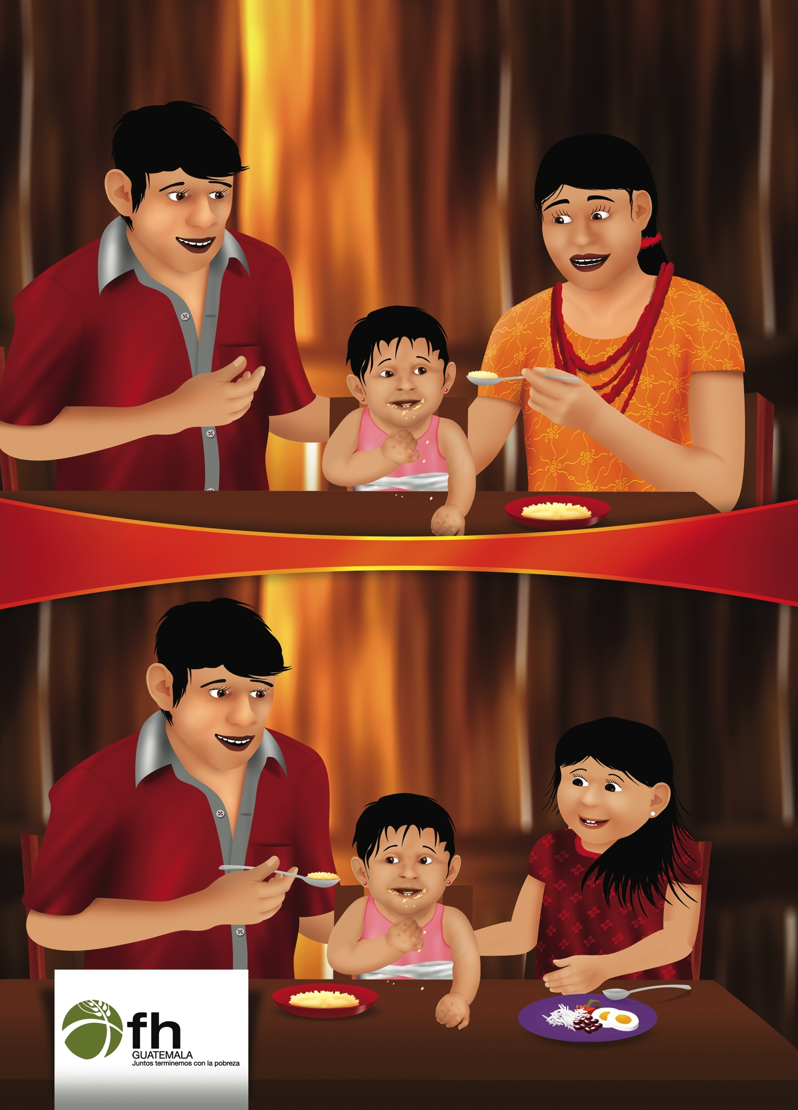
Other Caregivers Can Respond and Feed with Love (Picture 6.3)

6. Share the Meaning of Each Picture

- What do you think these pictures mean?

If you are away from your baby during the day, continue to speak with love to your baby while you are together.

Tell your caregiver that feeding responsively with love and affection is very important to you because it is very healthy for the baby.
- Show the caregiver several ways to do this with your child and encourage her to practice while you do it together.
- Thank the caregiver when she does this with your child.

- Do you have to be away from your baby during the day?
- What do others do when they need to work outside of the home?

Other Caregivers Can Respond and Feed with Love

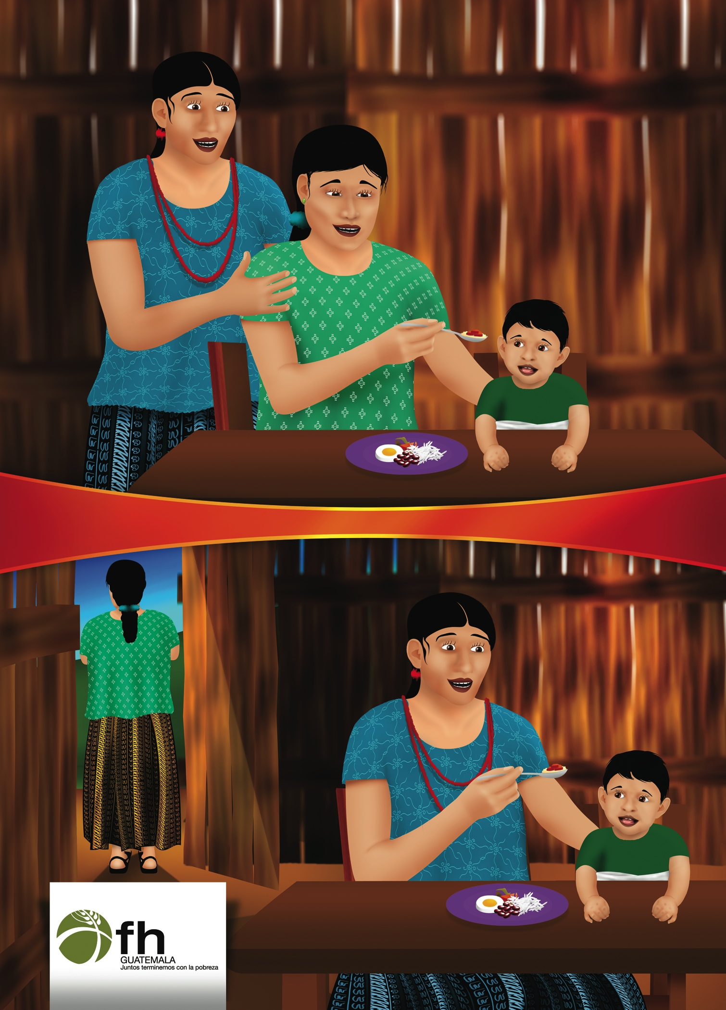
Sharing What We Know With Our Community (Picture 6.4)

7. Share the Meaning of Each Picture

- What do you think these pictures mean?

Our friends and neighbors can also be encouraged to feed responsively. Children grow well if their needs are listened to and responded to with love and affection.
- Use what you have learned from our time together when you are with your neighbors or family members.
- Others will learn by your example and be encouraged to try it at home with their babies.
- Sharing your knowledge and good practices with your neighbors show that you respect and trust them.
- Do you learn new things from your neighbors? What sorts of things?
- How do you show your neighbors that you love and respect them?

ACTIVITY: Responsive Feeding Role Plays | Discuss Barriers | Practice and Coaching | Request Commitments

Sharing What We Know With Our Community

