Knowledge Management
These core competencies can be used together with the TOPS Self-Rating Tool to adapt the TOPS Self-Assessment Toolkit to your needs.

Knowledge Management Advisor or Specialist
Knowledge Management (KM) staff lead the design and implementation of knowledge management initiatives within projects, programs, or organizations.
Due to the wide range of roles, responsibilities, and initiatives within the Knowledge Management sector in general, developing a ‘one-size fits all’ core competencies skill set is impossible. Core competencies will depend on the type of KM initiative being implemented but there are some comprehensive skills related to how knowledge is generated, captured, stored, managed, documented, shared, and utilized that will transfer across various sectors, initiatives, and organizations.
The set of competencies outlined here will therefore focus on those key skillsets in these areas that knowledge management practitioners within the international development/non-profit sector are expected to possess. The core competencies outlined below are specifically focused at the programmatic, rather than organizational level; and can in no way be considered exhaustive.
The KM advisor’s or specialist’s core competency areas include:
- Knowledge Management Concepts and Framework
- Knowledge Generation, Capture, Organization, and Synthesis
- Knowledge Sharing and Collaboration
- Knowledge Application for Learning and Decision-Making
- Measuring Knowledge Management Activities
In addition to the core competencies outlined below, there is also a set of critical inter-personal and personal skills that support KM practitioners in achieving their objectives. These include:
- Superior listening and convening skills: invaluable in coordinating activities across a wide range of stakeholders.
- Relationship-building, facilitation, negotiation and influencing skills: to garner support, buy-in, and sustained engagement of key stakeholders at various levels.
- Good written and oral communication skills: to facilitate smooth sharing and transfer of knowledge.
- Highly developed organizational skills: to enable effective prioritization and accomplishment of tasks.
- Accountability: assumes responsibility for results and delivers on commitments.
- The ability to deal with ambiguity.
- Working co-operatively with others.

Knowledge Management Concepts and Framework

Demonstrate an understanding of KM concepts and the purpose of effective KM in improving programmatic outcomes and efficiency.

Advocate the value of knowledge, learning, and KM.

Be able to conduct a knowledge audit to map existing knowledge and knowledge processes, identify unmet knowledge needs and gaps, outline available KM capacities, identify key stakeholders and critical success factors, and understand how these influence the intended goal(s) of KM activities.

Support the development of an appropriate KM Logic Model that includes problem analysis, inputs, activities, processes/outputs, outcomes, and impact of KM activities.

Support the development of a Learning Agenda to address critical knowledge gaps by prioritizing learning questions and planning and resourcing associated learning activities.

Support the development of a knowledge management strategy and associated work plan to guide implementation of KM activities and outline how KM processes take place.

Contribute to overall management of KM initiatives, including implementation, tracking progress, administering the budget, and assessing progress against the objectives.

Knowledge Generation, Capture, Organization, and Synthesis

Work with sector-specific technical staff to identify gaps in knowledge that may impede programming, and provide guidance on appropriate KM methods, strategies, and approaches to address these gaps.

Put appropriate mechanisms in place to ensure receipt of up-to-date knowledge and current information, new resources and tools that can augment a program’s knowledge and evidence base.

Know how to elicit and capture knowledge from both individuals and groups using approaches and tools such as structured interviews, process analysis techniques, wikis, lessons learned databases, knowledge repositories, Communities of Practice (CoPs), storytelling, video storytelling, share fairs, etc.

Ability to facilitate the selection, organization, and storage of knowledge in products, tools and systems designed for specific purposes (e.g., searchable database on best practices, directory of evidence-based practices, expert locators etc.).

Understanding of knowledge repositories and how to catalogue and organize content, provide access and retrieval, and establish policies for publishing, maintenance, and access.

Awareness of current technology to facilitate KM processes, and ability to recommend, deploy, use, and maintain the most appropriate technologies.

Understand how to collate and analyze information from a variety of sources to develop evidence to guide effective programmatic decision-making.

Adapt existing knowledge into actionable formats (fact sheets, summaries, eLearning courses, job aids, etc.) to create insights and new knowledge-based products that meet the needs of diverse audiences and contexts, instead of re-inventing the wheel.

Strong technical writing skills to transfer knowledge effectively via text.

Knowledge Sharing and Collaboration

Appreciate the value of sharing knowledge and information appropriately and readily share own knowledge, skills, and experience to enable others to meet their goals.

Seek experience, knowledge, and information from colleagues and ensure that these are accurately documented and disseminated.

Develop approaches with colleagues to build knowledge sharing into everyday work.

Alert colleagues to relevant new knowledge and experience and work with them to keep programmatic knowledge and evidence base updated.

Facilitate access to expertise in order to drive knowledge exchange and learning.

Know how to disseminate information in a way that is manageable and accessible.

Know how to implement knowledge-sharing methods such as interpersonal communication, case studies, brownbags, webinars, conferences, social media, social and virtual networks, field exchanges, etc.

Foster knowledge transfer among specific groups of people with common interests and goals such as CoPs.

Online facilitation skills to support the cultivation of CoPs and drive learning and engagement within virtual networks.

Competence with adult learning techniques that allow participants to be active learners.

Competence with facilitation and participatory learning techniques that can drive participation and enhance coordination and trust during peer exchange.

Identify, participate in, and promote cross-organizational collaboration, learning, and networking via face-to-face or online activities such as forums, training sessions, etc.

Identify barriers to collaboration and use appropriate strategies to improve collaboration and encourage knowledge sharing.

Cultivate and nurture internal and external relationships for collaboration and learning.

Develop alliances and partnerships for knowledge creation and transfer.

Know how to design, plan, facilitate, and host knowledge sharing meetings, conferences, and events.

Implement quality, user-friendly systems for communication, collaboration, and online information.

Represent the program in external meetings, conferences, and presentations on program-related KM topics.

Knowledge Application for Learning and Decision-Making

Willingness to learn from others―routinely check the experience of and consult with others before starting a new task.

Know how to find and select the knowledge needed for a task using appropriate tools and techniques.

Deploy activities such as After Action Reviews, program implementation reviews, lessons learned sessions etc. to drive continuous programmatic learning and improvement.

Coordinate with key stakeholders (key program staff, managers, technical specialists) to develop and implement action plans that incorporate key learning into program activities as appropriate.

Use M&E results from KM activities to adapt KM initiatives as necessary.

Identify and support evidence-based adaptive management efforts to better achieve intended program outcomes and impacts.

Measuring Knowledge Management Activities

Support the identification and/or development of indicators that measure progress of KM activities and objectives.

Lead or support the design of monitoring and evaluation and learning tools and data collection for KM indicators.

Interpret results to evaluate and report on impact of KM activities.
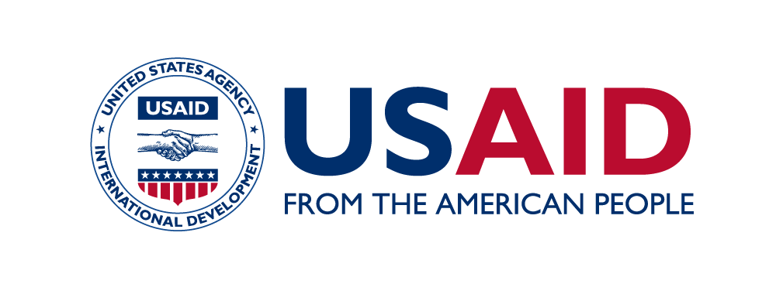
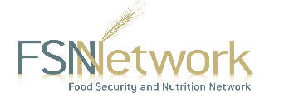
The Technical and Operational Performance Support (TOPS) Program is the U.S. Agency for International Development (USAID) Office of Food for Peace-funded learning initiative, bringing the highest quality information, knowledge, and promising practices in food assistance programming to implementers and donors around the world to ensure more communities and households benefit from the U.S. Government’s investments to fight global hunger.
The TOPS Program Core Competency Series is made possible by the generous support of the American people through the USAID. The contents are the responsibility of The TOPS Program and do not necessarily reflect the views of USAID or the United States Government.
This is Version 1 of the core competencies for Knowledge Management Advisors or Specialists, produced in January 2018.
The TOPS Program
899 North Capital Street, NE, Suite 900
Washington, DC 20002
info@TheTOPSProgram.org
The Core Competency Series was developed by staff from The Technical and Operational Performance Support (TOPS) Program with significant contributions from the various task forces of the Food Security and Nutrition (FSN) Network. The series intends to provide hiring managers, program managers, and program staff with explanations of the basic skills and knowledge senior technical staff may possess to carry out their positions effectively. Official job titles, functions, and requirements may vary based on organization and program.

