MODULE THREE

PARTICIPANT WORKBOOK FOR MANAGING DIVERSITY
Table of Contents

INFO SHEET A: THE FUNDAMENTALS OF PEOPLE MANAGEMENT AT CARE 134
INFO SHEET B: THREE PARADIGMS FOR MANAGING DIVERSITY 135
INFO SHEET C: MANAGING FOR DIVERSITY COMPETENCIES 136
INFO SHEET D: A DIVERSITY TREASURE HUNT 137
INFO SHEET E: CULTURAL DIFFERENCES……………………………………………………139
INFO SHEET F: DOMINANT AND SUBORDINATE GROUP MEMBERSHIP 140
INFO SHEET H: DIALOGUE SKILLS 142
INFO SHEET I: MANAGING FOR DIVERSITY LENSES 143
INFO SHEET J: WORKING STYLES 144
INFO SHEET K: TASK AND MAINTENANCE SHEET 145
INFO SHEET L: DECISION-MAKING TOOL 146
INFO SHEET M: SELF-ASSESSMENT TOOL 152

INFO SHEET A: THE FUNDAMENTALS OF PEOPLE MANAGEMENT AT CARE

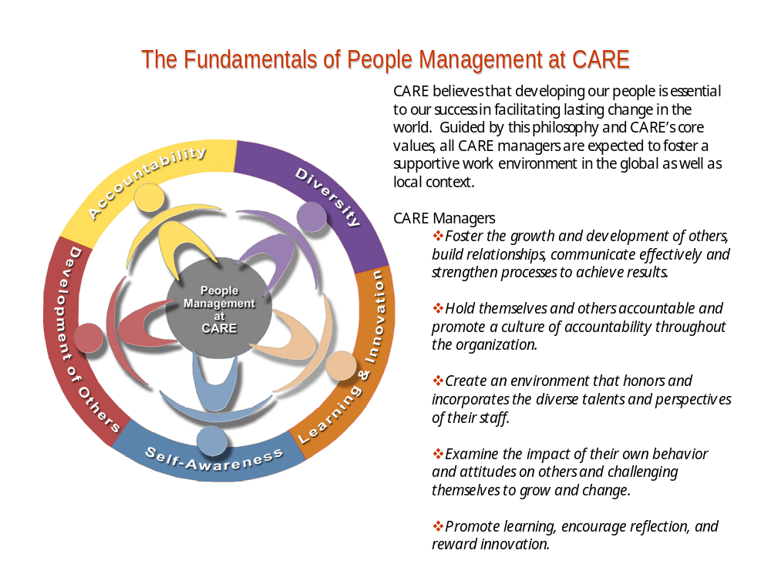

INFO SHEET B: THREE PARADIGMS FOR MANAGING DIVERSITY

⇒Managing for Discrimination and Fairness
This paradigm is based on the recognition that discrimination is wrong. Progress is measured by how well the company achieves its recruitment and retention goals and legal mandates.

Practical questions for managers:

How do I manage the ‘perception’ of discrimination?

Does bringing someone in leave someone else out?

How do I anticipate or handle ‘backlash?’

⇒Managing for Access and Legitimacy
This paradigm celebrates differences. The value of diversity manifests as organizations match internal demographics to targeted customers and clientele groups. This paradigm embodies issues of internal access and legitimacy – who has power, who is marginalized.

Practical questions for managers:
- How do I build trust between Dominant and Subordinate Groups?
- Who’s at the table, and who’s missing?
- How do I empower the marginalized?

⇒Managing for Learning and Effectiveness
Organizations adopting this paradigm are proactive in efforts to learn from diversity. These organizations thus effectively incorporate different perspectives into substance, structures and processes. Managers are encouraged to tap employees’ differences for creative ideas, innovation and to make explicit use of cultural experiences.

Practical questions for managers:
- How do I capitalize on diverse resources to warrant better outcomes?
- How do I facilitate the necessary working atmosphere for solutions to emerge organically from a diverse group of employees?
- How can I help myself and others learn and continue to grow on issues of diversity?

INFO SHEET C: MANAGING FOR DIVERSITY COMPETENCIES
Competency One
Exhibiting sensitivity to and respect for the perspectives and interest of those from different cultural backgrounds, belief systems and world-views
Competency Two
Demonstrates awareness of power relations and status and advocates for fairness and equal opportunity in decision-making and in implementing policies and procedures
Competency Three
Actively promoting dialogue, reflection and shared learning about diversity
Competency Four
Promoting diverse representation and broad participation in all group activities
Competency Five
Actively seeking and incorporating diverse ideas and thoughts in plans and actions

INFO SHEET D: A DIVERSITY TREASURE HUNT

Find as many of these treasures as you can within a 30-minute time period, using the people in this room as a resource.

- Two different suggestions for how CARE could improve its relationship with the African-American community in Atlanta.

- Two different ideas about how to deal productively with the white male backlash phenomenon.

- Two different ideas about how to help balance work and family life at CARE.

- A story about the role of community in strengthening the individual.

- Two different suggestions for how to improve relations between national and international staff in Country Offices.

- An innovative idea relating to Girls’ Education programs from someone who has never been involved with such programming.

- Two widely different approaches to managing the situation described below.

Scenario: Brian, who is openly gay, approaches his manager, Bill, to complain about harassment in the workplace. He feels that Matthew, another member of the team, is homophobic. He reports that Matthew makes negative comments about homosexuality and treats him disrespectfully. Bill has also noticed that Matthew seems to have an ardent and vocal view- deeply rooted in his religion and culture- of homosexuality as bad. What does Bill do?

- Two widely different approaches to managing the situation described below.

Scenario: You notice that Fatma, a Somali refugee who has recently started working at CARE, is very quiet in staff meetings and never offers her own thoughts or opinions. You are concerned she will never advance if she cannot speak up. What do you do?

- One thing about each of the following religions [or the experience of being part of that religion] that will help you be more sensitive to practitioners of that faith: Judaism, Hinduism, Buddhism, Christianity, Islam.

- A story about successfully accomplishing a task or project from a setting where time is cyclical and expansive rather than linear and limited, or from a setting where relationships are the significant factor rather than task.

- One thing learned by an American who has spent significant time overseas that has changed his/her life profoundly and has had a positive influence on his/her work.

- One thing lost and one thing gained by someone from another country who has spent significant time in the USA.

- One gem of wisdom that an American who has never worked overseas can share about being part of a global workforce.

- A metaphor for working at CARE from someone who has been in the organization for less than two years.

- A metaphor for working at CARE from someone who has been in the organization for more than 15 years.

- A gem of wisdom about how to address poverty from someone who has lived it directly.

- A gem of wisdom from someone with dominant group membership about the resource s/he brings from that experience.

- One recommendation to the Executive Team about how to hold staff accountable for promoting diversity.
INFO SHEET E: CULTURAL DIFFERENCES

In multi-cultural studies, two primary types of cultures have been identified: high-context [or ‘being’] cultures, and low-context [or ‘doing’] cultures.

High-context cultures are those in which the group shares a large range of experiences, beliefs, and assumptions. Interactions occur within that shared context, which is known to all and often unspoken. The culture is more interested in the quality of relationships within that context than in accomplishing tasks. Examples of high-context cultures include most traditional Asian, African, Latin American, African American and Indigenous cultures.

Low-context cultures are those in which individuals are not so highly socialized into the same set of beliefs, assumptions and behavioral norms, and so are more concerned with the individual and what s/he does than with the quality of relationships. Examples of low-context cultures: highly industrialized societies, such as in the U.S. [Caucasian] and Europe.

These distinctions are of course not rigid or pure as many cultures are in flux and there exist sub-cultures within larger cultures. That said, the general characteristics of these two types of culture are:

Low-Context/’Doing’ Cultures | High-Context, ‘Being’ Cultures
Focus is on individual | Focus is on group (family or clan)
Emphasizes getting the job done | Emphasizes quality of relationships
Sees time as linear | Sees time as cyclical
Speaks in rational, declarative mode | Speaks in stories, metaphors
Is present and future oriented | Sees past as essential part of present/future
Is merit-based | Is shame-based (saving ‘face’*)
Sees nature as something to control | Sees nature as essential part of life
‘I’ identified | ‘We’ identified
Values individual wants and needs | Values group wants and needs
Speaks directly, ask for what you want | Speaks indirectly, doesn’t refer to self
Is rewarded for accomplishments | Is rewarded for alignment with group norms
Serves personal needs first | Serves group needs first
Questions for Reflection:
- What is my cultural context?
- Given my cultural context, what do I need to do in order to appreciate the different contributions that others can bring?
- What are some possible stereotypes I hold about other cultural contexts?

INFO SHEET F: DOMINANT AND SUBORDINATE GROUP MEMBERSHIP
In intergroup relations, power dynamics usually revolve around those with power and those without power. In other words, people belonging to the group with more power by virtue of their identity have Dominant Group Membership. Those belonging to the group with less power by virtue of their identity have Subordinate Group Membership.

Some factors to consider in group dynamics:
- Because everyone has multiple and changing group memberships, many people experience both Dominant and Subordinate Group Membership sometime in their lives.
- Dominant Groups do not necessarily constitute the majority groups [13% of world’s population is white].
- Subordinate Group Membership does not suggest ‘submissive’ attributes of its members.
- Dominant and Subordinate group dynamics exist everywhere in the world

DOMINANT GROUPS | SUBORDINATE GROUPS
See themselves as individuals | Are aware of their ‘groupness’
See their behavior as normal | Often experience themselves as outsiders or different from the dominant group
Benefit from an environment structured according to their norms, leading them to see subordinated groups as substandard | Must assimilate to dominant group in order to advance. Often internalize dominant groups’ beliefs of their lack of worth
See subordinate members as a part of a group or carry negative judgments about them [Projection]. | Know more about dominant groups than dominant groups know about them
Have the power to limit access to resources and/or behavioral options to non-group members | Have curtailed access to resources
Have advantages they did not earn by deeds, but merely by virtue of some identity attribute | Work extra hard for the same status or advantages enjoyed by the dominant group
Are unconscious of their privilege and how it is embedded within the norms and structures of society | Are often painfully conscious of their lack of privilege and the unfriendly norms to which they have to conform
Encourages subordinate members to develop behaviors pleasing to dominant members | Develop characteristics intended to please dominant group members
Focus on one’s intent rather than the outcome | Focus on the impact/outcome of behaviors
Do not understand subordinate group realities | Often adopt the norms and realities of the dominant group in order to advance and/or survive
See own group as superior or see a few ‘good ones’ as exceptions to the subordinate group’s norm | Sometimes imitate dominant members and/or act destructively toward other subordinate group members for survival
See incidents of discrimination as individual actions of other people that have nothing to do with them. | Identify patterns of behavior quickly because of repeated treatment [Collective impact]
Subtly require other dominant members not to get too close to subordinate members | Do not always react directly and honestly to negative treatment but rather indirectly and covertly
Often encourage dissention between and among subordinate groups | Often distance themselves from one another in order to fit in or advance in the system
Do not think of themselves as oppressors | Have solidarity with one another due to shared struggle
INFO SHEET G: CONDITIONING SCREENS

What are ‘Conditioning Screens’?
Repeated Messages
Current Realities
Historical Resonance
Collective Unconscious
Everyone has a set of perceptual screens through which they view (or hear) others. These screens are built up over time and reinforced by four interconnected factors that keep us from seeing each other as we truly are in this moment.

1. Repeated Messages – words, phrases, ideas, images we receive over and over again from the media, from our parents, and in our social milieu. Examples: for women, that thin is beautiful; for white people, that white is normative and superior.

2. Historical Resonance – historical traumas, experienced at the individual or group level that still resonate in current situations and color the present with feelings and assumptions carried over from the past. Examples: the lasting effects of slavery and Jim Crow; anti-semitism and the Holocaust.

3. Current Realities – real situations in the present experience of people that reinforce Repeated Messages and trigger Historical Resonance. Examples: an incident of violent gay-bashing; racial profiling by the police; structural inequities in housing or education.

4. The Collective Unconscious – basic assumptions that are buried deeply in the consciousness yet affect one’s actions. Example: association of white with good and pure; black with dark and evil.

How do Conditioning Screens affect our work at CARE?
- It can contribute to or exacerbate a perception of discrimination, marginalization, or victimhood;
- It can contribute to a sense of ‘us versus them’;
- It can be become an unconscious and unspoken sub-text to current relationships;
- It can be an obstacle to our meeting people as they truly are, and to being in a conversation or a relationship of unconditional regard.

How can I, as a manager, be sensitive to addressing this phenomenon?
- Be aware that the phenomenon exists.
- Be alert to places where your own experience of the four Conditioning Screens may be distorting your view of a situation or of another
- Be attentive to possible moments when other peoples’ experience of the four Conditioning Screens may be distorting their view of a situation or of you.

If you sense these screens may be distorting a communication or a relationship, try to name the experience you are having and unravel the different threads. Bringing them into consciousness, without blame or shame, can turn the situation into a learning experience.

INFO SHEET H: DIALOGUE SKILLS

- Discovery Mode: to understand; willingness to be changed
- Sharing Truth: sharing truth of your personal experience; ‘I’ statements
- Active Listening: giving full attention to content, meaning, feelings
- Surfacing Assumptions: uncover beliefs that underlie opinions, ‘facts’
- Suspending Judgments: put judgments aside to hear better
- Attending to the ‘Whole’: notice themes, patterns and implications
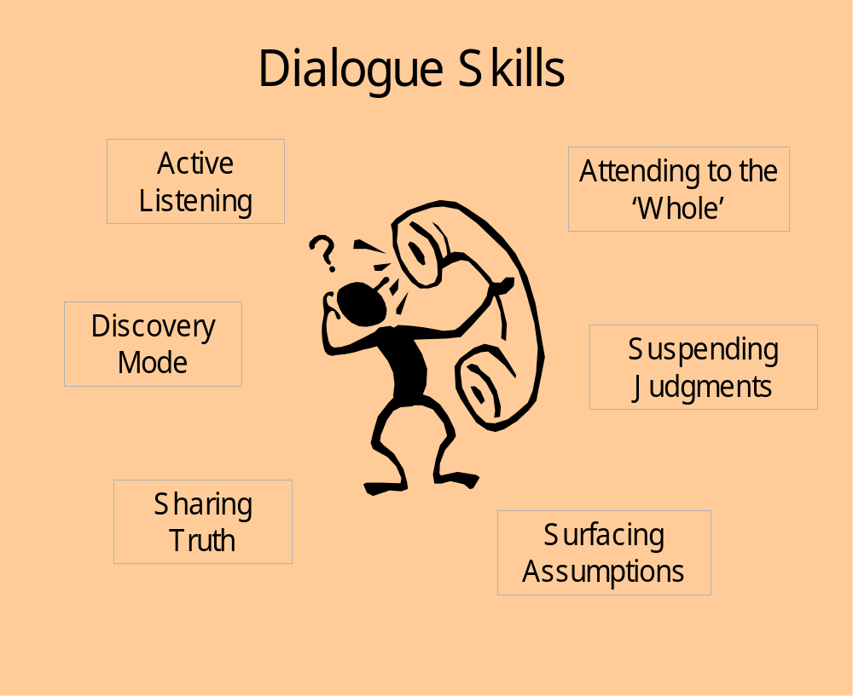

INFO SHEET I: MANAGING FOR DIVERSITY LENSES

Dominant/Subordinate Group Membership
Working Styles
Conditioning Screens
Cultural Differences
Diversity Competencies
Decision-
making
Task-Maintenance Balance
Managing Diversity
Learning and Effectiveness Management Paradigm

INFO SHEET J: WORKING STYLES

A combination of different working styles can enhance or hinder a team’s effectiveness. Most individuals carry a dominant or core working style in approaching work, and it is important to understand how a combination of and respect for different styles can contribute to innovation and creativity in problem solving or decision-making. The model below provides a simple illustration of the different styles and characteristics that accompany them.

ANALYTICAL  - Does job correctly  - Likes facts and figures  - Focuses on steps and objectives  - Seeks logical explanations  - Want to be right  - You do what it takes to be right  - Not overtly aggressive  - I told you so!  A | DRIVER  - Gets the job done  - Likes results  - Focuses on results  - Seeks most efficient way  - Chip on the shoulder  - Tell me I can’t do it!  - Leaders  - Need others, don’t like to admit it  - Analytics pull you back  B
C  AMIABLE  - Works cooperatively  - Likes people and fairness  - Focuses on process  - Seeks informality  - Grease the wheels  - Get people to work together  - Focus on relationships  - Not so aggressive  - Let criticism eat at them | D  EXPRESSIVE  - Works enthusiastically  - Has vision  - Focuses on hunches  - Seeks stimulation  - Not universally liked, but needed  - Question later on – should we be doing this?  - Big picture/visionaries  - Easily bored, want to move on

Questions for Managers:
- What is my dominant workstyle? How does this impact how I approach my work?
- How do I respond to different workstyles in a team? How can I be sensitive to them?
- Do I use different workstyles as a resource in decision-making or problem solving?

INFO SHEET K: TASK AND MAINTENANCE SHEET

In every group there are two functions that must be managed:

Task-
the completion of the work or purpose

Maintenance –
the quality of the process, so that people feel good about being part of the group

Behaviors that further the task include: | Behaviors that further maintenance include:
Summarizing a discussion | Making space for silent members to speak
Checking for agreement | Attending to feelings
Re-focusing a conversation that wanders from the central task | Ensuring a psychologically (and physically) safe space
Giving clear instructions | Encouraging creativity
Setting clear goals | Creating a sense of team, or belonging-ness
Holding self and others accountable for accomplishing goals | Respecting differences
Meeting timelines | Sharing appreciations

INFO SHEET L: DECISION-MAKING TOOL

This document is created for the purpose of helping CARE clarify its decision-making processes, on the assumption that such clarity improves both employee morale and the quality of output.

I. The Decision-Making Model
This model has two components:
- Four different types of decision-making processes (Executive, Consultative, Consensus, and Self-Authorized)

- The contextual issues to consider when determining which decision-making process to employ (Cost, Time, Impact, and Morale; how the decision and how it is reached will foster the vision of CARE and its Rights-based and Diversity initiatives)

II. Decision-Making Processes
- Self-Authorized. People are able to make certain decisions on their own, and on their own behalf, without consultation or discussion with others. They are, of course, always accountable to their supervisor for the results of such decisions. Most staff make self-authorized decisions all the time, relating to their scope of work. The boundaries of which decisions can be self-authorized and which need to be checked with one’s supervisor should be discussed between employee and supervisor.

Example: Employee has two meetings to attend simultaneously. They determine for themselves which meeting they will attend.

- Consensus. In this process, decisions are taken jointly by several parties acting in collaboration. The group tries to reach unanimity; however, if that is not possible, a general consensus emerges and parties who do not concur agree, at minimum, that they can live with it and are willing to support it. Consensus decisions are generally appropriate when a number of parties will be required to collaborate on the outcome of the decision. They are also appropriate in partnership arrangements.

General guidelines for reaching consensus:
- Make space for each voice to be heard
- Listen for the general ‘sense of the group’
- Summarize the discussion occasionally to make sure key points are being captured
- Test for consensus (‘do we all agree that....?’)
- Make sure that dissenting views are aired fully
- Ask dissenters if they can live with, and support, the emerging consensus

If you cannot reach consensus:
- Take a time break, and come back to the conversation at another time
- Negotiate with each other, listening for the interests behind the positions of each party; seek areas of common ground, compromise, and, if necessary, bartering (“I’ll agree to this if you will do that....”)
- If negotiation fails, ask an agreed-upon third party to mediate, helping the group arrive at a decision together
- If mediation fails, take the decision to an agreed-upon third party for arbitration. In this case, all parties agree to abide by the decision of the arbitrator, who listens to all views and renders a decision.

Example: Employees from different units or divisions have limited office space in a building and have to agree how the space will be allocated.

- Consultative. In this case, there is input from a variety of parties, but the decision rests with a single individual. Some consultative processes are mandated by policy (e.g., hiring panels); others are initiated by someone who has the authority to make a decision on their own, but chooses – for any number of reasons – to get input from others.

General guidelines for the decision-maker:
  - determine who should be part of the consultation, either as individuals or in a group
  - communicate clearly that what is sought is consultation, not consensus decision-making
  - seek diverse perspectives
  - set up a clear consultative process
  - listen respectfully to all input
  - let the input inform your choices in ways that most make sense to you
  - inform those who participated in the consultation what your decision is, share your reasoning if you desire, and thank them for their participation.

General guidelines for those involved in the consultation:
- be clear that you are involved in a consultative process, not a decision-making process; if not clear, ask
- share your views freely and thoroughly
- if a decision is made that is other than what you suggested, it doesn’t mean you have not been respected or heard; do not take it personally

Example: A supervisor asks a hiring panel to interview candidates seeking feedback on the candidates and recommendations for the hire; then makes the hiring decision.

- Executive. In this situation, a person has the authority and is empowered to make decisions on behalf of others, and chooses not to engage in a consultative process. This type of decision-making is appropriate when there is a time constraint, when the issues are clear, or when consultation would not add significantly to the quality of the decision. Please note: the use of the word ‘executive’ here does not connote someone in the Executive Division, but rather refers to a situation where someone has the authority to execute a unilateral decision that affects others.

Example: The Director of Security mandates that all CARE employees must travel with CARE badges shown at all times when traveling in East Africa.

III. The Contextual Issues for Selecting a Decision-Making Process
For most of the work day, most people are making self-authorized decisions. The boundaries of that process are set, as said previously, between employee and supervisor. For the other three processes, however, there may be times when it is not obvious which decision-making process is most appropriate. There are four general factors that form the context for deciding how to decide. These are:

- Cost. Who will have to pay for the outcomes of this decision? If money will come out of someone else’s budget, perhaps they should be included in the decision (either consultatively or consensually). What are the organizational or political costs of making this decision in one way or another? What are the likely hidden costs?

- Time. What are the time constraints around this decision? How soon do you have to have a clear answer? How much time would it take to engage in a consultative or consensus process, and is that consistent with your timelines and deadlines? How much time will you have to give to explaining why you didn’t engage in a consultative or consensus process, if you choose to make an executive decision?

- Morale. How will the process you choose affect the morale of those you work with? How will it impact those who are not invited to participate? Those who are? How can you use the decision-making process to heighten morale?

- Impact. What will be the impact of your choice for a decision-making process on other tasks on your to-do list, in your work unit, on other parts of the organization?

Clearly, there will be times when considering these factors leads to a situation of competing values. For instance, you must agree on a job description for a new position in your unit. You highly value the opportunity a consensus process will give to improve the morale of the work team on which this new hire will function. However, your timeline is such that you need this person immediately if not sooner. You have competing values, between time and morale. What do you do?

In cases of competing values, it is important to acknowledge the struggle, even as you choose one over the other. If, for instance in the example just given, the time element is more critical than the morale factor, explain to your people that this was the situation, you had to make a tough choice, and it doesn’t mean you don’t value their input. Remember that, lacking information, people will make assumptions and create story-lines about your behavior. Therefore, rule of thumb – share the information that went into your decision.

Finally, in determining which decision-making process to use, please also consider the congruency of process and goal. This is often called ‘walking your talk.’ How does your chosen decision-making process foster (or not) the vision of CARE? How does it relate to CARE’s commitment to a Rights-based approach and to its Diversity initiative?

IV. Enhancing Diversity Through Decision-Making

When working within a participatory decision-making process (consultative or consensual), how can you insure that diverse viewpoints are invited and included? There are four elements to consider:

1. Voice. Who is at the table? Who is missing? Do people feel safe to talk? Who has a vested interest in this decision? Who will be impacted by it? How is ‘voice’ given to different views that arise from people’s experiences with their culture, world view, working style, gender, ethnicity, etc.?

2. Involvement. Who is heard? Who is not heard? How are issues of status managed? Do people with higher status have greater influence, more air time? Do people with lesser status or different cultural assumptions about authority hold back from participating? How can you involve the more silent members of the group?

3. Fairness. What is the general perception of fairness about the decision-making process and about the final decision? Who feels treated fairly; who doesn’t? Pay attention to the feedback loop. Let people know what the outcome is and why.

4. Trust – Is trust enhanced or decreased through this process? Do people feel they are respected; that they can trust the process to truly take into consideration what is important to them?

These four elements affect one another, as in the diagram:
VOICE
INVOLVEMENT
FAIRNESS
TRUST

As people feel their voice matters, they are more likely to participate more fully. The more people participate safely and satisfactorily, the more they are likely to feel treated fairly. The more people feel treated fairly, the more trust they will feel – for the individuals involved, for the process, and for the organization.

V. How to Use This Tool
This document lays out a set of information about the kinds of decision-making processes that might be employed at CARE, and the things to consider in choosing and implementing any one of those processes. Some suggestions for how to use this tool include:

- Discuss With Your Team. Set aside at least two hours to sit with your work team, your unit, or whatever the appropriate set of co-workers may be, to discuss this document. Try to map out certain categories of decisions that will always default to a particular decision-making process, so that you do not have to have the conversation over and over again. For instance, you may agree that decisions involving the creation of a new project will always be done by consultation.

Of course there will always be exceptions, and unexpected circumstances, but to the extent that you can create a clear template in advance for choosing the appropriate decision-making processes, you will save time and energy in the long run. You can also use this time for people to clear the air about previous decisions for which there are left-over bad feelings, acknowledging that this document is in part an attempt to minimize such situations in the future.

- Use This as a Checklist. Post this document, or some simplified version of it, near your desk or computer, and refer to it as you would to a checklist whenever you are wondering what type of decision-making process to employ.

- Use This as an External Standard. When people disagree over anything, the differences can be resolved more easily when you can refer to an external standard. This de-personalizes the conversation, and moves it from an oppositional ‘I say this, you say that’ forum to one in which both (or all) parties are looking to the same objective source. If you cannot agree with others in your work setting about which decision-making process is appropriate, refer to this document as a guideline.

INFO SHEET M: SELF-ASSESSMENT TOOL

The following questions pertain to each Diversity Competency. For each behavior, please rate yourself on a scale of 0-5; with 0=Don’t Know; 1=Never; 2=Rarely; 3=Sometimes; 4=Often, 5=Always. Circle the answer that best fits you. At the bottom of each category, please put the total score for that group of questions (add up the four numbers circled).

I. Exhibiting sensitivity to and respect for the perspectives and interests of those from different cultural backgrounds, belief systems and world-views
0=Don’t Know; 1=Never; 2=Rarely; 3=Sometimes; 4=Often; 5=Always

- I show respect and acceptance for people from backgrounds and experiences different from my own.
Don’t Know 1 2 3 4 5

B. I am aware of the major differences between ‘low context’ and ‘high context’ cultures, and can notice when these differences are at play in a work situation. Don’t Know 1 2 3 4 5

C. I manage the performance review process with a sensitivity to cultural and personality differences.
Don’t Know 1 2 3 4 5

D. I am sensitive to the ways people from other identity groups have adapted to the culture of the dominant society, in the US and at CARE. Don’t Know 1 2 3 4 5
____ Total score for category I

II. Demonstrates awareness of power relations and status and promotes fairness and equal opportunity in decision-making and in implementing policies and procedures
0=Don’t Know; 1=Never; 2=Rarely; 3=Sometimes; 4=Often; 5=Always

E. I promote fairness and equal opportunity in hiring, promotion, and career development. Don’t Know 1 2 3 4 5

F. I advocate for the dignity and rights of people with less status and power in the work setting. Don’t Know 1 2 3 4 5

- I am aware of, and can address with sensitivity, the historical grievances and hurts that may influence the perspective of people. Don’t Know 1 2 3 4 5

- I am aware of the dynamics inherent in the relations of those with dominant group membership and subordinated group membership, and seek to actively balance and share power to counter the effects of these dynamics.
Don’t Know 1 2 3 4 5

____ Total score for category II

III. Actively promoting dialogue, reflection, and shared learning about diversity
0=Don’t Know; 1=Never; 2=Rarely; 3=Sometimes; 4=Often; 5=Always

I. I engage in reflection and ongoing learning about diversity with self and others. Don’t Know 1 2 3 4 5

J. I hold myself accountable to master and display the Diversity Competencies.
Don’t Know 1 2 3 4 5

K. I promote opportunities for self and others to express curiosity and widen knowledge about the different customs, worldviews, and perspectives of others. Don’t Know 1 2 3 4 5

L. I facilitate safe space and an environment that encourages honest dialogue, trust, innovation, and risk-taking. Don’t Know 1 2 3 4 5

____ Total score for category III

IV. Promoting diverse representation and broad participation in all group activity
0=Don’t Know; 1=Never; 2=Rarely; 3=Sometimes; 4=Often; 5=Always

M. I actively solicit representation from a wide range of actors to reflect the diversity on the team, or in the community being served. Don’t Know 1 2 3 4 5

N. I condemn – explicitly – any actions that discourage participation from a wide range of actors. Don’t Know 1 2 3 4 5

O. I encourage my direct reports to seek unconventional sources when solving problems. Don’t Know 1 2 3 4 5

P. I provide the space and time for broad participation in day-to-day activities. Don’t Know 1 2 3 4 5
____ Total score for category IV

V. Actively seeking and incorporating diverse ideas and thoughts in plans and actions
0=Don’t Know; 1=Never; 2=Rarely; 3=Sometimes; 4=Often; 5=Always

Q. I incorporate and integrate different perspectives and approaches when making decisions. Don’t Know 1 2 3 4 5

R. I actively seek and publicly value input from people with different perspectives and ways of operating. Don’t Know 1 2 3 4 5

S. I notice who’s ‘not at the table’ and I make an effort to include missing voices. Don’t Know 1 2 3 4 5

T. I have a personal improvement plan for increasing skills in managing diversity, and I make time to check in with a ‘buddy’ to assess progress. Don’t Know 1 2 3 4 5

____ Total score for category V

Your Personal Managing for Diversity Profile
Now create your own personal Managing for Diversity Profile. For each of the five competencies on the horizontal line, place a dot at the corresponding point on the vertical line that indicates your total score in that area. Then connect the dots. This will show you at a glance where your strengths are, and the areas in which you need to develop greater skill.

20====================================
-
-
-
-
15====================================
-
-
-
-
10====================================
-
-
-
-
5====================================
-
-
-
-
=====================================
Competencies: One Two Three Four Five

EVALUATION FORM

Managing Diversity

- Overall quality of the training:
Poor………………………………………………………………………………………Excellent
Scale: 1 2 3 4 5

- What were helpful elements of the program?

- Not helpful elements of the program? How can they be improved?

- Other topics or training to use in future sessions?

- Rate the trainer(s) on the following characteristics:
Poor………………………………………………………………………………………Excellent
Scale: 1 2 3 4 5

Responses:
- clarity of presentations: 1 2 3 4 5
- knowledge of subject: 1 2 3 4 5
- team work: 1 2 3 4 5
- flexibility: 1 2 3 4 5
- ability to facilitate useful learning experience:
1 2 3 4 5
- Additional Feedback for trainer(s)?

- Two things you learned or re-learned today? Share highlights

Based on a Harvard Business Review article, ‘Making Differences Matter: A New Paradigm for Managing Diversity,’ by David Thomas and Robin Ely.
Backlash phenomenon: when white men see women or minorities getting wanted positions and feel it is reverse discrimination. Backlash can manifest as frustration, negative energy.
This information is based on the work of Edward T. Hall.
*’Face’ refers to honor. Thus one loses ‘face’ if one is embarrassed, humiliated, disrespected, or otherwise dishonored in front of others. It is important not only to save one’s own ‘face’ but also to insure that one is not the cause of another losing ‘face.’ Thus a person in this type of culture would never do anything that might embarrass another or make them feel bad (e.g., might not say ‘no’ to a request because it might make the asker feel bad).
This piece builds upon the work of Elsie Cross Associates
Developed by Pat Battle and Louise Diamond
Please note: in some cultures, “I” statements would not work. The emphasis here is on sharing the truth of the experience, and to explore how this can be shared in a way that is acceptable in a given context.
From the work of L. Sylvester, 1998.
Created for CARE by Louise Diamond, Lee Butler, and Walter Fordham
‘Low context’ cultures focus on the individual; emphasize getting the job done; are present and future-oriented; is merit-based and serves personal needs first. ‘High context’ cultures focus on the group; emphasize quality of relationships; value group needs and speak indirectly.

