Nutrition and Food Technology
These core competencies can be used together with the TOPS Self-Rating Tool to adapt the TOPS Self-Assessment Toolkit to your needs.

Nutrition Advisor or Specialist
A nutrition advisor or specialist (or a maternal and child health and nutrition advisor or specialist) provides input to program management for the design of program strategies for nutrition. They lead the implementation of nutrition activities with responsibility for ensuring quality through staff capacity-strengthening, supportive supervision and monitoring.
The nutrition advisor or specialist’s core competency areas include:
- Conceptualizing malnutrition
- Anthropometric assessment of nutritional status
- Nutrition guidance for the first 1,000 days
- Micronutrients
- Recommended infant and young child feeding (IYCF) practices
- Nutrition and food aid commodities
- Maternal and child nutrition indicators
- Nutrition and water, sanitation, and hygiene (WASH)
- Program design and implementation

Conceptualizing Malnutrition

Understand the framework for looking at the immediate/basic, intermediate/indirect, and underlying causes of malnutrition.

Understand the rationale for focusing on the first 1,000 days.

Know the key indicators of child malnutrition—wasting, stunting, underweight, and overweight—and their relative importance in the program location.

Know the key indicators of micronutrient deficiencies—maternal and child anemia, vitamin A deficiency, and any others of public health importance—and how to analyze their relative importance in the program location.

Know how to assess food consumption patterns in the program location and how to analyze their relation to macronutrient or micronutrient deficiencies.

Anthropometric Assessment of Nutritional Status

Know how to accurately measure acute malnutrition using mid-upper arm circumference (MUAC) and weight-for-height.

Know how to measure stunting using height-for-age.

Know how to measure weight-for-age.

Know the cutoff points for the classification of malnutrition as mild, moderate, or severe.

Know how to use supervision tools to monitor the quality of anthropometric measurement conducted to assess nutritional status.

Nutrition Guidance for the First 1,000 Days

Understand the Essential Nutrition Actions (ENA) and their potential contribution to achieve program objectives.

Identify pertinent IYCF materials, including those created by national governments and UNICEF, and understand their potential contribution to achieve program objectives.

Know how to identify any additional guidance for maternal nutrition before, during, and after pregnancy and understand their potential for contribution to program objectives.

Know how to identify any additional guidance for adolescent nutrition before, during, and after pregnancy and understand their potential for contribution to program objectives.

Micronutrients

Know government policies and procedures for addressing key micronutrient deficiencies.

Know additional guidance and programmatic ways to address maternal anemia, child anemia, and vitamin A deficiency.

Know which locally available foods are high in micronutrients and how these foods can contribute to optimal diets for women, infants, and children.

Know which foods and beverages inhibit or assist the absorption of micronutrients.

Recommended Infant and Young Child Feeding Practices

Know the advantages of immediate breastfeeding at birth, including advantages for the mother and the infant.

Know the rationale for exclusive breastfeeding for the first 6 months.

Have the skills to support optimal breastfeeding, including correct position and latch, and to solve common breastfeeding problems, such as mastitis.

Know the rationale for continued breastfeeding to at least 2 years of age and its nutrient contribution to the child’s diet.

Know the rationale for introducing complementary feeding at 6 months of age.

Know the recommended frequency, amount, consistency/texture, density, and variety of nutrients for complementary feeding of infants and young children at 6–8 months of age, 9–11 months of age, and 12–23 months of age.

Know which locally available foods support optimal complementary feeding.

Know responsive/active feeding techniques.

Know the recommended practices for feeding sick children during and after (recuperative feeding) illness.

Know the recommendations for best IYCF practices in areas with high HIV prevalence.

Nutrition and Food Aid Commodities

Know how food aid rations are calculated.

Know the nutrient contribution of food commodities in the existing ration.

Know how locally available foods can contribute the nutrients needed to transition from the receipt of food commodities at the appropriate time.

Maternal and Child Nutrition Indicators

Know how to calculate the early initiation of breastfeeding.

Know how to calculate rates of exclusive breastfeeding for children under 6 months of age.

Know how to calculate minimum meal frequency by age range for children 6–23 months of age (part of the Minimum Adequate Diet composite indicator).

Know how to calculate minimum dietary diversity by age range and breastfeeding status for children 6–23 months of age (part of the Minimum Adequate Diet composite indicator).

Know how to calculate the Women’s Dietary Diversity Score (WDDS) or the Minimum Dietary Diversity for Women indicator (MDD-W).

Know how to set targets for maternal and child nutrition indicators.

Nutrition and Water, Sanitation, and Hygiene

Know the relationship between diarrhea, other illness, and nutritional status.

Identify the Essential Hygiene Actions (EHA) and understand their potential contribution to achieve program objectives.

Know the requisites of safe food preparation and storage.

Know the latest research findings on environmental enteric dysfunction (EED) and nutrition.

Identify other activities focused on infants and EED (“baby WASH”) and understand their potential contribution to achieve program objectives.

Program Design and Implementation

Know how to use one or more tools for program design, such as the Nutrition Program Design Assistant (NPDA).

Know how to design activities for the prevention of malnutrition.

Know how to identify the appropriate level of effort and ways to collaborate with other partners for nutrition recuperation activities.

Know how to use one or more methods for formative investigation.

Know how to review and prioritize key maternal and child nutrition practices.

Know how to assess “persons of influence” for nutrition behaviors and appropriately incorporate these actors into program activities.

Know the key concepts (“essential elements”) of Care Groups.

Know the key concepts (“essential elements”) of Mother-to-Mother Support Groups.

Know the key concepts of the Nutrition Assessment, Counseling, and Support (NACS) approach in areas with high HIV prevalence.

Know ways to build on additional community group structures.

Know how to transfer skills for group facilitation and one-on-one counseling to program staff and actors at the community level.

Know how to assess the local food context and identify food sources high in macronutrients or micronutrients.

Know how to develop a seasonal calendar of food availability.

Know how to use Food Composition Tables.

Know how to promote nutrition-sensitive agriculture within integrated programs.

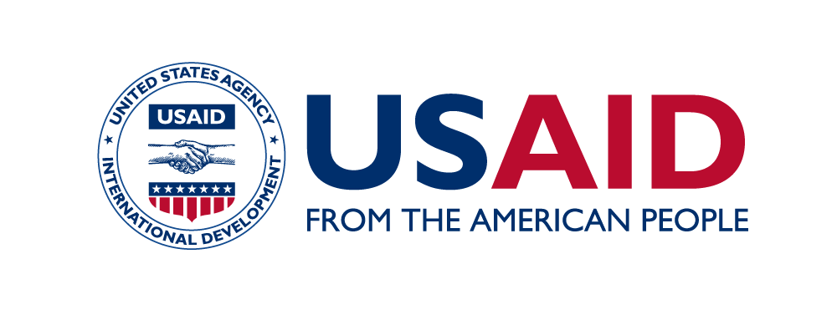
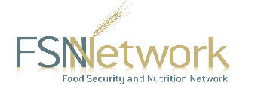
The Technical and Operational Performance Support (TOPS) Program is the U.S. Agency for International Development (USAID) Office of Food for Peace-funded learning initiative, bringing the highest quality information, knowledge, and promising practices in food assistance programming to implementers and donors around the world to ensure more communities and households benefit from the U.S. Government’s investments to fight global hunger.
The TOPS Program Core Competency Series is made possible by the generous support of the American people through the USAID. The contents are the responsibility of The TOPS Program and do not necessarily reflect the views of USAID or the United States Government.
This is Version 1 of the core competencies for Nutrition Advisors or Specialists, produced in September 2015.
The TOPS Program
899 North Capital Street, NE, Suite 900
Washington, DC 20002
info@TheTOPSProgram.org
The Core Competency Series was developed by staff from The Technical and Operational Performance Support (TOPS) Program with significant contributions from the various task forces of the Food Security and Nutrition (FSN) Network. The series intends to provide hiring managers, program managers, and program staff with explanations of the basic skills and knowledge senior technical staff may possess to carry out their positions effectively. Official job titles, functions, and requirements may vary based on organization and program.

