

*Adapted from the Essential WASH Actions Training and Reference Pack[1]*

This was designed for Amhara, Ethiopia. Please feel free download and customize (e.g. foods, names and other culturally specific items. Please credit appropriately: Rosenbaum and Bery, FHI360 2017. Artwork @Peter Gottert, FHI360)

CREATING A SAFE ZONE FOR INFANTS

TO KEEP THEM FROM HARM

*This 30-minute interactive session is designed for mothers and caretakers of infants and young children. Open the discussion by saying you want to talk about some hidden dangers in the home, and how the mother can take actions to protect her child and help her grow.*

**Steps:**

**Show 2 pictures:**

1. Picture of firfir
2. Pile of poop with flies.

**Say:** It’s time to feed your 7-month baby child.

Which food will you give him/her??

1. Enjera and sauce or…
2. a pile of poop with flies.

**Ask:** Would you give firfir? Or give poop??

*Don’t wait long for an answer… it’s not a serious question…*

**Say:** Of course, no one would knowingly feed feces to their child!

**Ask:** Do you remember the commitment your community made to end open defecation?

At that time, the community went on the walk of shame, to examine how feces makes its way into our food and water.

**Ask:** Did you take part in that?

*Explain the community commitment to end open defecation*

* When people poop in the open, in the fields and bush, the rain and flies and animals carry it around and spread it, causing it to get into our food and water …. until we end up doing the unthinkable … eating our neighbors feces!
* That’s why we build and use latrines, to keep feces out of our food and drinking water.
* Your community made a commitment to end open defecation, and achieved this great accomplishment. That’s why you have the big blue sign at the entrance to your community, telling residents and visitors of your commitment to total hygiene and sanitation.

**But there are OTHER ways that feces work their way into our CHILDREN’S mouths and into their food and water. We’re going to tell a story about how our children end up doing the unthinkable, eating feces.** We’ll tell a little story, to discover some ways our infants are exposed to harm. We’ll then talk together about what can be done to create a safe zone for your child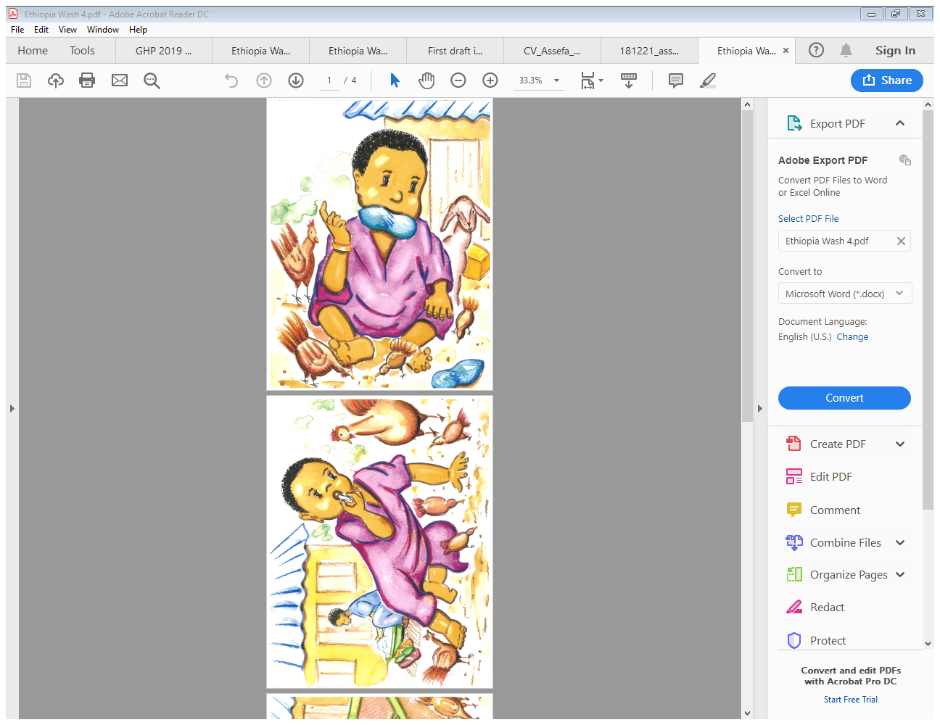.

*Give Mother Picture 2 to hold and review, while you tell the story in a fun, lively way. Don’t just read, act it out!*

Story: What Did Your Child Eat Today?

Fekerte comes back to her compound after collecting firewood. She takes her seven-month child Tigist off her back and puts her on the ground while she unloads the firewood and checks around the compound. She is tired already just thinking of all the chores ahead of her this afternoon and decides to get started. **Mama Fekerte washes the baby clothes that have been soaking while she was out… and throws the soiled wash water near Baby Tigist … making Tigist clap her hands with glee!** Whosh!

Tigist is getting stronger by the week, and she crawls over with her favorite baby doll to the puddles and begins to play… slapping the water, making it a game, exploring. **She grabs some of the wet dirt, and puts it in her mouth, and wipes the rest on her shirt. Baby giggles and does it again,** this time feeding some to her doll. The chickens play all around the yard, and she tries to chase one, but isn’t yet a fast-enough crawler to catch the energetic bird.

*Now share picture #3 with the mother:*

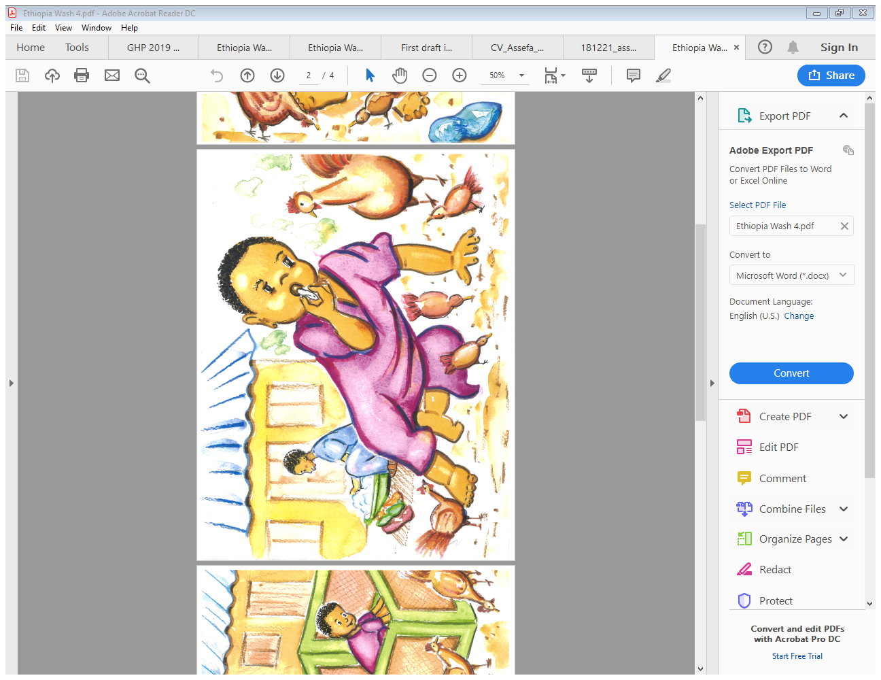

Mrs. Fekerte is busy sorting through the beans and is relieved to see her sister Hiwot come back from the field where she has been all morning. Hiwot can help watch the baby. As her sister walks toward the house, Mama Fekerte shouts after her*… I just swept.. make sure you clean your muddy shoes before you go inside!* Her sister Hiwot sits on a stool by Baby Tigist, takes a stick from the woodpile, and gets all the mud off her shoes. She sings to Tigist and tells her she’ll be back after she goes inside.

Tigist is delighted at all the new things to explore… chunks of dirt from Hiwot’s shoes, plastic containers, all sorts of things to explore like babies love to do. While her mom is busy in the courtyard, she takes a few more tastes from the treats in the dirt… crawls into the shade and takes a nap beside the chickens and the dog.

Mama Fekerte is ready to start cooking the yekik alicha …. She readies the fuel for the fire, taking a dung cake drying in the sun. She calls her sister, who comes from behind the house wiping her hands on her skirt. Hiwot picks up Tigist’s toy from the yard and puts in on the ground beside where she is sleeping goes to help her sister with the meal.

**ASK:**

1. What is your reaction to this story?
2. Do you know any families that are like Mama Fekerte’s?
3. Together let’s make a list of all the things that Baby Tigist put into her mouth?

*Let the mother answer, and after each answer say. “Anything else?” When she’s given all the answers she can, add the ones she didn’t mention.*

Possible answers include:

* chicken feces
* mud/dirty water

• soil from the field

• pebbles

* toys
* her fingers

1. Can you tell me which of these things might have had feces on them?

*After she lists some, say* HARD TO BELIEVE, BUT ALL OF THEM!

Because, as we learned when committing to end open defecation, anything that touches feces – our hands, the flies, the dirt … and then touches something else … well, in the end, it spreads the human and animal feces ALL AROUND, and COVERS IT with feces.

And sometimes we can SEE IT, but many times it is invisible and we can’t. That’s why we wash our hands even if we don’t see the dirt… and why we need to monitor and limit the items the baby touches and puts to their mouths.

**SAY:** There are many ways animal and human feces get into babies’ mouths, or into their food and water.

This talk makes us more aware of where the DANGER of FECES may be in the compound.

**Ask:** Did the story of Mama Fekerte and Baby Tigist make you think that feces may be in our compounds?

Remember, babies learn from exploring and putting things in their mouths. It’s good to let them explore, but we need to limit what they can reach, and be mindful of everything going into their mouth.

Besides the baby putting their hands and mouth on objects that may have been touched by feces, one other way babies get eat feces is directly eating soil that is unknowingly mixed with feces!!

Eating soil is very popular with babies, even moms do it when they are pregnant. But did you know that compound soil often is mixed with both human and animal feces?

While it may taste sweet, it’s just like eating a spoonful of poop!!

*Something we would NEVER DO! And never feed our children, for sure.*

**THAT’S WHY WE ARE SUGGESTING YOU THINK ABOUT HOW TO CREATE A SAFE ZONE FOR YOUR BABY, AN AREA IN THE COMPOUND THAT YOU PROTECT AND KEEP EXTRA CLEAN.**

**Outreach Worker:** Use the *mikikir negotiation technique*

**Ask:** Let’s look at the possible solutions together… what do you think you could do to help separate your child from animal, feces and dirt?

*Wait for an answer*

***ASK:***

* What are things you can do around your compound to create a safe zone for your child?

**Listen** to their answers, and ask, anything else?

**Ask** what else… over and over, and add from the list below.

Ask:

* What makes it difficult to make sure children don’t get exposed to dirt and waste?

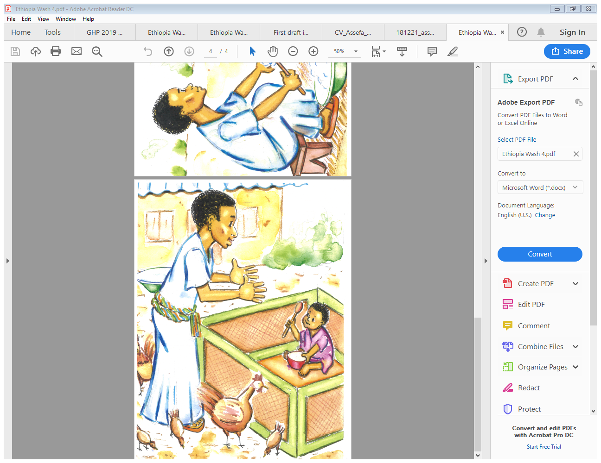**Now turn to the playpen:**

This playpen is designed to help you create a safety zone for your child, to keep them from eating feces and dirt, from putting dirty items into their mouths. We’d like to leave it here with you for a few weeks, to try and see if it helps to create a safe zone for your baby.

**Whenever you would normally put the baby to the ground, use the playpen instead and put the baby there.**

***Show Image 4*** *(at right)*

It helps us watch our children closer and monitor what goes into their mouths.

**It’s a nice piece of furniture, something that adds prestige to your yard.** You can use it outside in the compound as you go about your chores, and if you want use it inside too.

**Ask:** Do you think you could try using the playpen with your baby?

*Ask the following questions, and then do the mikikir to problem solve:*

What will make it hard to use it?

Will anyone approve or disapprove?

**So, can you commit to me you’ll try to use this playpen for at least a few hours every day??**

***Show Image 5***

Remember YOU still need to watch your child while in the pen. It makes it easier to talk and sing to him or her, too.

Here are 5 other things you need to know:

1. NEVER PUT THE PLAYPEN NEAR TO THE FIRE, EVEN IF YOU THINK THE BABY IS COLD. THE MATERIAL CAN CATCH ON FIRE.
2. IF YOU THINK THE BABY IS COLD, PUT ON MORE CLOTHING TO WARM HIM. PLEASE DON’T ADD BLANKETS OR PILLOWS BECAUSE THEY COULD SUFFOCATE…
3. Please DON’T PUT THE PLAYPEN ON A BED OR RAISED PLATFORM… THE BABY COULD FALL OVER.
4. You will want to clean the mat whenever it looks dirty, and at least every 3 days.
5. Dedicate just a few items they can explore and play with in the playpen. Also you need to clean anything you put in the playpen whenever it looks dirty, or every 3 days.

Are you agreed to try this?

You can do this Mama!!!

Any questions??

*Fill out the certificate of merit and have the mother and father sign!*

**ASK the mother**: What is the most important things that she remembers from this discussion?

Ask further: Are there any other important things to remember?

**COMMEND the mother** on what they remember and fill in those key points that they do not mention. Key points include:

1. Babies learn by putting things into their mouths. We caretakers need to monitor carefully everything that goes into the child’s mouth.
2. When your child eats soil or licks his/her fingers after touching soil or dirty objects, it can make him/her sick. Sometimes the sickness is not immediate, but it can have effects for the rest of the child’s life.
3. It is important to keep your child from eating soil and other mouthing objects in the yard.
4. A good way to keep your child from eating soil is to CREATE A SAFE ZONE, to keep that area swept and feces free. And place him/her in the playpen where you see him/her at all times.

Go over the 7 essential behaviors with the mother:

1. Create a safe zone for your baby.
2. Put the baby into the playpen instead of onto the ground.
3. Put the playpen away from fires, wells, and animals.
4. ALWAYS make sure you can see the play area or mat.
5. Watch your baby, and ALWAYS stop your child from eating soil or chicken poop.
6. Provide your child with a few washable, safe toys to play with in the play space.
7. ALWAYS keep the playpen and the toys clean by washing them with soap and water whenever they look dirty, and at least every 3 days.

**ASK THE MOTHER TO ENCOURAGE OTHERS IN THE HOUSEHOLD TO MAKE SURE THAT THE CHILD STAYS IN THE PLAY AREA OR ON A PLAY MAT WHEN IN THE YARD AND ENSURE THE CHILD DOES NOT EAT SOIL OR CHICKEN FECES.**

!

**Images**

**Image 1**

**What are we feeding our children??**

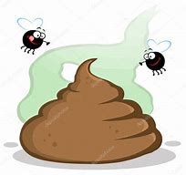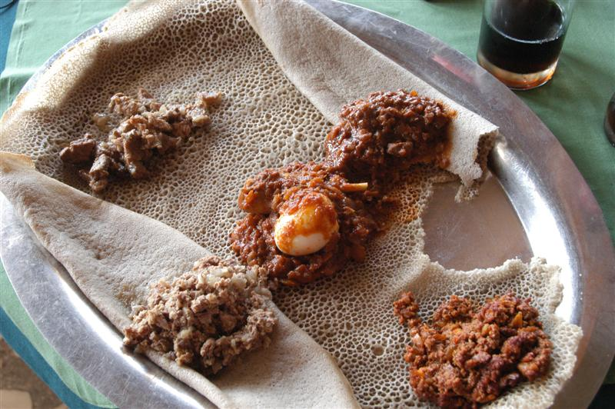



Image 2



Image 3



Image 4 52]

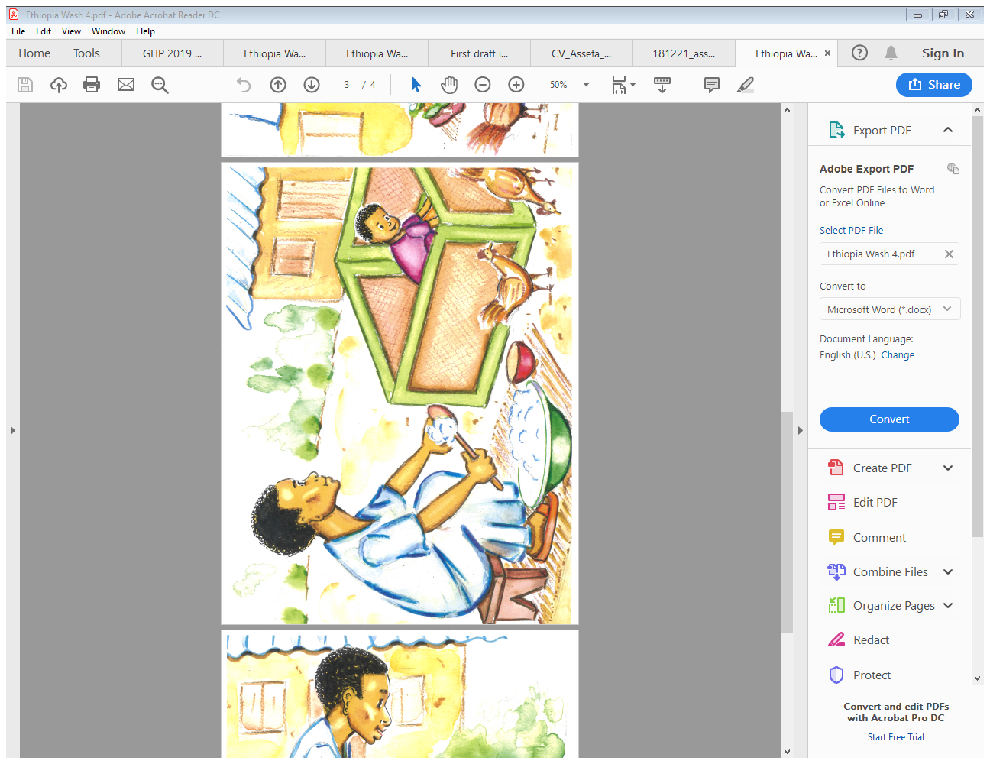

Image5

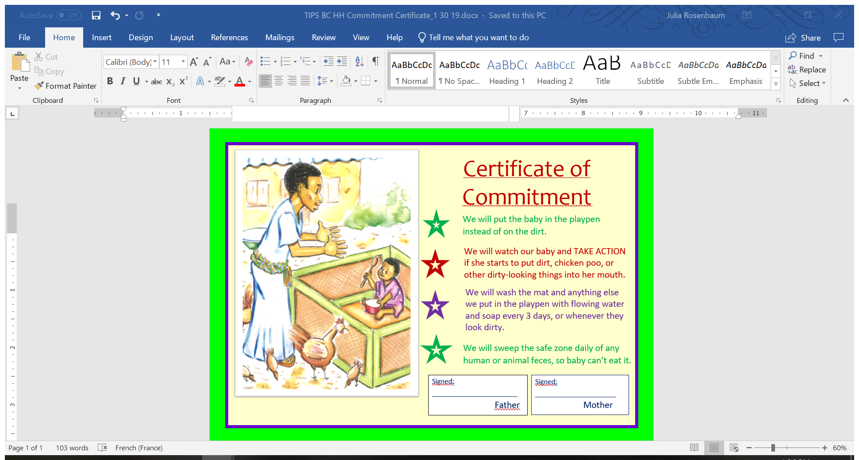

1. *Adapted from Essential WASH Actions, a collaborative resource guide edited by Julia Rosenbaum and Renuka Bery (FHI360) through USAID funds. Please use and adapt with proper credit. All illustrations @Peter Gottert. The authors acknowledge the previous work of the behavior change module used in the SHINE Trial in Zimbabwe.* [*https://clinicaltrials.gov/ct2/show/NCT01824940*](https://clinicaltrials.gov/ct2/show/NCT01824940)*.* Full Essential WASH Actions found [here](https://www.fsnnetwork.org/essential-wash-actions-training-and-reference-pack-supplement-essential-nutrition-actions)